**Welcome**

Welcome to Python: Not for Dummies! In this book, I will be using Python and its libraries with applications of advanced mathematics. Python is one of the most widely used programming languages in the world, and its popularity is growing by the day. One of the key reasons for this growth is its simplicity and the vast array of libraries available that can be used for a wide range of tasks. These libraries can help to simplify and streamline programming, allowing developers to focus on building great applications and software without having to reinvent the wheel. In this book, I will provide a comprehensive introduction to some of the most popular Python libraries. Whether you're a complete beginner to programming or an experienced developer looking to expand your knowledge, this guide will help you to get up to speed with the essential Python libraries that you need to know. We will cover everything from data analysis, web development, machine learning, and even game development, providing practical examples and step-by-step guidance to help you get started with each library. By the end of this book, you'll have a solid foundation in Computer Science and in some of the most popular Python libraries. When you finish, hopefully you will have the skills you need to start building your own applications and projects. So, whether you're a student, a hobbyist, or a professional developer, let's dive in and get started!

**What is Computer Science?**

Before we get to know Python, we need to understand what Computer Science is. When people think of Computer Science, they think of typing out endless amounts of code. Though code is a part of Computer Science and it is what produces the final product, there is much more in this field. Computer Science is a fascinating and rapidly growing field that has become an essential part of modern life. It is a discipline that deals with the study of computers and computational systems, and how they can be used to solve real-world problems. At its core, Computer Science is concerned with the development of software and systems that are efficient, reliable, and secure. By studying Computer Science, students learn how to analyze problems, design solutions, and implement them in code. As technology continues to advance, the importance of Computer Science only grows, as it is the driving force behind many of the innovations and advances that we see today, from the development of machine learning algorithms to the creation of virtual reality environments. Computer Science has transformed the way we live, work, and communicate, and has revolutionized many industries. Despite its many complexities, Computer Science is a rewarding and exciting field that offers many opportunities for those who are interested in pursuing a career in technology. With the right skills and knowledge, graduates of Computer Science programs can go on to become software developers, data scientists, network administrators, cybersecurity experts, and much more. This book is an introduction to Computer Science, and aims to provide readers with a broad overview of the field, as well as an understanding of some of its key concepts and applications.

**What is a Library?**

Before we get started, what is a library? In computer science, a library is a collection of pre-written code or software modules that can be used by developers to simplify the process of software development. A library typically contains a set of functions or procedures that perform specific tasks, such as handling input/output, networking, or graphics. Libraries are designed to be reusable, so that developers can use them across multiple projects without having to write the same code over and over again. They can be included in a program's code to provide additional functionality or to perform complex operations. Libraries can be either standard libraries, which are included as part of a programming language, or third-party libraries, which are created and maintained by individuals or organizations outside of the language's core development team. Some popular examples of libraries in computer science include NumPy for numerical computing, Pandas for data analysis, and TensorFlow for machine learning.

**What Libraries are in this book?**

The libraries that we will be using include NumPy, Pandas, Matplotlib, TensorFlow, Flask, PyGame, the built-in libraries, and maybe some miscellaneous ones if I feel like it. Quick introductions: NumPy is used for numerical computing with arrays, Pandas is used for data analysis for large sets, Matplotlib is used to create visualizations, TensorFlow is used for deep learning applications and things like object detection, Flask is used to build web applications, and PyGame is used to build games. Built-in Python libraries like sys, os, math, string, etc. are used throughout the book and many of the different examples, so it is important to understand those as well.

**Installing Python**

Before we can program in Python, we need to have it installed! To install Python, look up Python Download on your browser or go to this link: <https://www.python.org/downloads/> and download the latest release. Note: The operating system should automatically fit to whatever you are using, but double check to make sure. When you open the installer, keep all of the settings to default, but check to make sure of the box that says Add to PATH. This is really important if you are going to be using a coding editor like Visual Studio Code, which is what I am going to be using in this book. If you are using an IDE like PyCharm, you do not need to worry about adding to PATH or even downloading Python, but it is better to have them downloaded for later use. After you finish installation, go to the Command Prompt and type in the command (python --version) to check if Python installed correctly. If it replies the right version of Python, you are good to go and can move on.



Success!

**Pip installer and Powershell**

Before we can install our desired libraries, we have to install “Preferred Installer Program”, or better known as PIP. PIP is a package manager for Python, which is a tool used to install, manage, and uninstall Python libraries and dependencies. PIP allows users to easily install and update Python packages and their dependencies, and it automates the process of downloading and installing packages from the Python Package Index (PyPI). PIP is included with Python distributions, so it is generally readily available to Python users. PowerShell is a command-line shell and scripting language developed by Microsoft for Windows operating systems. PowerShell is designed to automate and streamline system administration tasks and is capable of interacting with a wide range of system components and services. It includes features such as command-line editing, command completion, and the ability to access .NET Framework objects and data stores. PowerShell also includes a scripting language with features such as variables, functions, and loops, which allows users to create scripts to automate repetitive tasks or perform complex operations. PowerShell is often used by system administrators, developers, and IT professionals for tasks such as managing servers, automating tasks, and performing system maintenance. We will be using PowerShell and PIP throughout this book, and it is good to know how they are used. As stated before, PIP should automatically download with python and you can check by using the command **pip --version** in PowerShell or the Terminal. If it gives you a version number, you are all set and can start coding in Python.

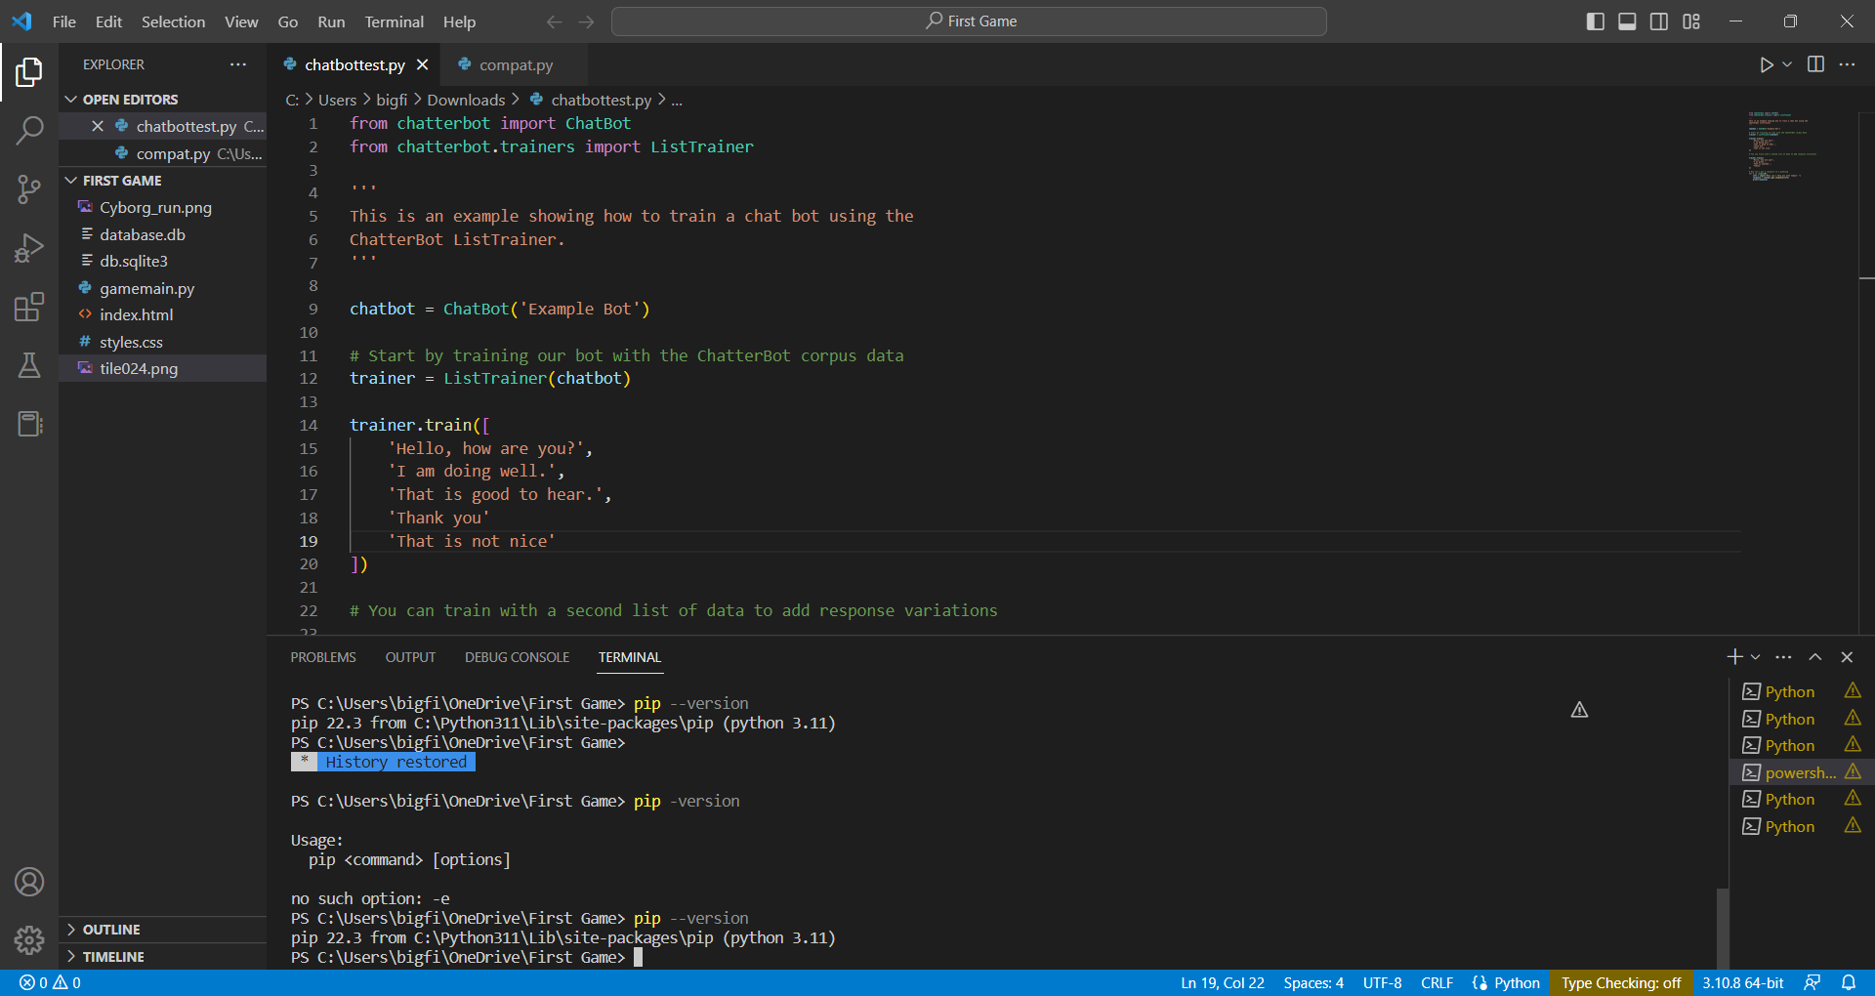

Success!

**Disclaimer**

This book is intended for readers with some prior knowledge and experience in computer science. It is not suitable for absolute beginners or those without any background in programming or related fields. While efforts have been made to explain concepts and terminology in a clear and concise manner, readers without prior exposure to computer science may find some sections of this book challenging or difficult to follow. I wrote this book assuming that readers have a basic understanding of programming fundamentals. Therefore, readers should assess their own familiarity with these subjects before attempting to read this book.

**Installing Libraries**

PIP makes it really easy to install libraries in Python. The simple command to install a library is **pip install (enter library name).** For example, to install the pandas library, the command would be **pip install pandas.** To download a specific version of a library the command is **pip install (enter library name)=(version).** For example, to install pandas version 1.5.3, the command would be **pip install pandas = 1.5.3.**

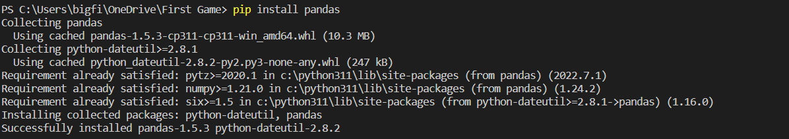

Success!

If the terminal does not say successfully installed your library, check if you are in the python terminal or the powershell terminal. The python terminal will not work if it does not have administrator access.

**Upgrading PIP**

Once in a while, PIP itself will have an upgrade and sometimes PIP will not work without the upgrade, so it is recommended to always have the latest version of PIP. The command to upgrade PIP is **python.exe -m pip install --upgrade pip.**

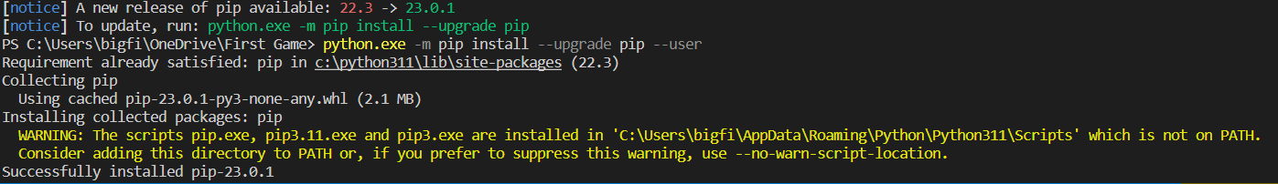

Success!

If you are getting this error: **Could not install packages due to an EnvironmentError: [WinError 5] Access is denied**, add --user to the end of the command. This tells PIP to install packages in some specific directories within your home directory. For our purposes, this is okay to do and will install the package without any errors.

Command: **python.exe -m pip install --upgrade pip --user**

**NumPy**

Finally, we are done with the boring stuff. Let’s get started with NumPy. NumPy is a Python library that stands for "Numerical Python". It is a fundamental package for scientific computing in Python that provides support for large, multi-dimensional arrays and matrices, as well as a wide range of mathematical functions to operate on these arrays. NumPy is widely used in scientific computing, data analysis, and machine learning. It allows users to perform mathematical and logical operations on arrays with lightning-fast speed, making it a crucial component for many applications where performance is critical. Some of the key features of NumPy include: Powerful N-dimensional array object, broadcasting functions for arithmetic operations on arrays, tools for integrating C/C++ and Fortran code, linear algebra, fourier transform, and random number generation capabilities, comprehensive documentation and large community support.

Now that you know what NumPy is used for, let’s start learning about it. Start by installing the NumPy library. If you forgot the command: **pip install numpy**.

**Creating an array**

Before we can start doing computations with arrays, we have to know what an array is and how to create one in NumPy. An array is a data structure that stores a collection of elements of the same data type in a contiguous block of memory. In other words, an array is a way to store a fixed-size collection of elements of the same data type. Arrays are commonly used in programming because they allow for efficient storage and access of data. They are particularly useful for performing mathematical and statistical operations on large amounts of data, as they provide a convenient and efficient way to store and manipulate data. In many programming languages, including Python, arrays are implemented as built-in data types or as part of a standard library. The NumPy library in Python provides a powerful array object that is widely used in scientific computing and data analysis. To create an array in NumPy, look below.

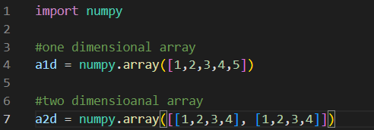

To create higher dimensional arrays, just nest arrays into arrays into arrays into arrays…

**More Array Creation**

The example above showed how to create an array using a Python list, but there are a couple built-in functions that NumPy created that you can use to make it easier.

**Creating an array with a range of values: numpy.arange(start, stop, step)**

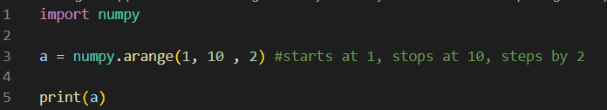

Output: [1 3 5 7 9]

**Creating an array of random values: numpy.random.rand(rows, columns)**

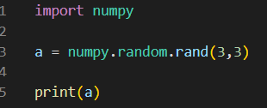

This should create a 3x3 array with random values

**Output example: [[0.84771668 0.80585392 0.6746017 ]**

**[0.02742464 0.05697861 0.95906306]**

**[0.54918595 0.06170082 0.81490483]]**

**To find more array creation functions, go to this link:**

[**https://numpy.org/doc/stable/user/basics.creation.html**](https://numpy.org/doc/stable/user/basics.creation.html)

**Indexing on one dimensional NumPy arrays**

Indexing an array refers to the process of accessing an individual element within an array by using its position, or index, within the array. In Python, and most programming languages, arrays are zero-indexed, which means that the first element in the array has an index of 0, the second element has an index of 1, and so on. For example, if we have an array of integers named myArray, and we want to access the third element of the array, we can do so by using the index 2, like this:

**myArray = [1, 2, 3, 4, 5];**

**thirdElement = myArray[2];**

To show the element on the terminal, simply print the variable thirdElement.

Indexing in NumPy works exactly like how it does in the Python Standard Library.

To index a NumPy array that we created before, simply use this code:

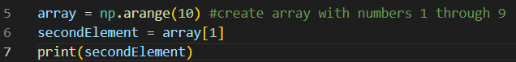

The output for this code should be the number “1”, as it is the second element in the array. Notice that the index used to get the second element was 1; remember, the first element has the index 0.

Python also allows negative indexing, which basically counts backwards. For example:

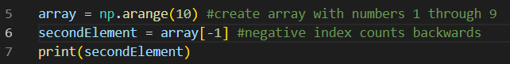

The output for this code should be the number “9”. Notice that the new index number used is -1. When you use -1, the computer selects the last element in the array because again, the first element in the array is 0, so when you count backwards by 1, the element chosen is the last element in the array.

Did you get into your head that arrays in Python start with the index 0 yet? Yes? Good. Time to move on.

**Indexing on two dimensional NumPy arrays (Matrices)**

Indexing a 2D array in NumPy is a little different than the standard Python library, but they are both pretty simple. 2D arrays are also a little more complicated than single dimensional arrays. Remember the fact that the first element of the array has index 0? Yeah I do too. Well, in a 2D array, the furthest top-left number has the 0th “x” and “y” index. And to index that number in the standard Python library, we have to use double brackets instead of single brackets. For Example:

**# create a 2D array with 3 rows and 4 columns using nested lists**

**my_matrix = [[1, 2, 3, 4],**

**[5, 6, 7, 8],**

**[9, 10, 11, 12]]**

**# access a single element at row 1, column 2 (i.e., element with value 7)**

**print(my_matrix[1][2])**

This code's output should be 7.

Now let's do this in NumPy

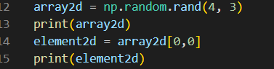

Notice how you can index with a single bracket. This does not really make it easier but it is a cool feature for indexing 2D arrays in NumPy

Output:

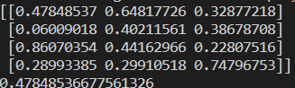

Note: The top left value in a 2D array has the x and y index of 0

**Importing data with genfromtxt()**

The function genfromtext in NumPy that allows you to load data from a text file or a file-like object and create a NumPy array from it. It is a flexible function that can handle a variety of input formats and options. The basic syntax for using genfromtxt is:

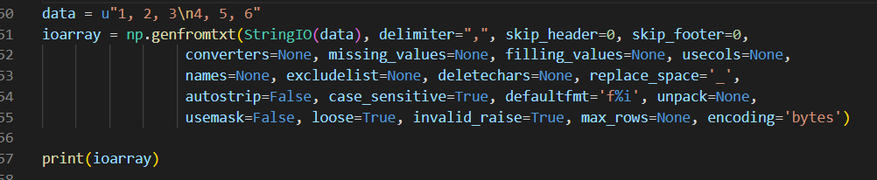

Now I know all of those parameters look confusing, but you can see that in this example, most of those parameters are set to None or just blank. The descriptions for the parameters are listed below:

fname: The name of the file or file-like object to read data from.

delimiter: The delimiter used to separate values in the file. If not specified, genfromtxt will try to infer the delimiter automatically.

skip_header: The number of rows to skip at the beginning of the file.

skip_footer: The number of rows to skip at the end of the file.

dtype: The data type of the resulting array. If not specified, genfromtxt will try to infer the data type automatically.

usecols: A tuple or list of column indices to extract from the file. If not specified, all columns will be read.

names: A boolean or list of strings indicating whether to treat the first row as column names. If a list of strings is given, these will be used as column names.

missing_values: A string or sequence of strings indicating values that should be treated as missing.

filling_values: A sequence of values to use as replacements for missing values.

converters: A dictionary mapping column indices or names to functions that will be used to convert the corresponding values during parsing.

**Vectors with NumPy**

Now I know the word vector sounds confusing, you are not alone, I was also scared when I first heard the term vectors, like I mean they sound confusing. But do not worry, vectors are basically the same thing as a 1D array. Before I explain why this is, we need to understand what a vector is in the first place. A vector is a mathematical object that has both magnitude and direction. They are typically represented by an ordered list of numbers, or coordinates, that describe its direction and magnitude in each dimension. Vectors can be used to represent physical quantities like velocity, acceleration, or force, and they are also widely used in linear algebra and other areas of mathematics. On the other hand, a 1D array is a data structure that stores a collection of elements of the same type, arranged in a single dimension. In programming, 1D arrays are often used to represent lists, sequences, or vectors (in the mathematical sense). The reason why vectors and 1D arrays are often used interchangeably is that they share many similarities. Both vectors and 1D arrays have a fixed length, they can be indexed to access individual elements, and they can be used to perform various mathematical operations like addition, subtraction, and dot product. However, there are also some differences between vectors and 1D arrays. For example, vectors have a clear geometric interpretation in terms of direction and magnitude, while 1D arrays are purely abstract data structures. Additionally, vectors are often used in mathematical contexts where the operations performed on them have specific meanings, whereas 1D arrays can be used more generally for storing and manipulating collections of data. So while vectors and 1D arrays share many similarities, they are not exactly the same thing.

You can create a horizontal and vertical vector using the same methods that you created a numpy array with.

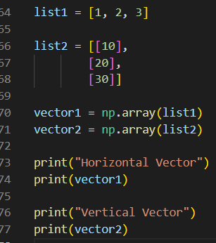

This code shows how you can create horizontal and vertical vectors using lists and numpy. Looks simple right? We will be doing more fun stuff with vectors later.

This is the output for the code shown on the left.

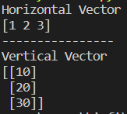

**Simple Vector Arithmetic with NumPy**

Doing arithmetic on vectors in python is really simple so I am not going to spend a lot of time on it. To do arithmetic, you can simply add, subtract, multiply, or divide both vectors. If you really want to check, you can do the math by yourself. For example:

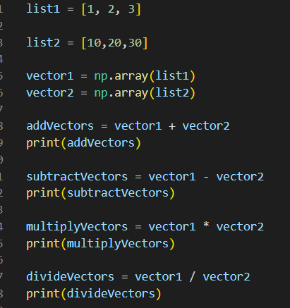

**The code to the left shows simple arithmetic being used on 2 vectors. One application that might use vector arithmetic is the field of game development. Game Developers use vectors to represent things like movement, position, and velocity of game objects.**

Output:



**Coding Problem #1**

Yes, there are going to be some coding problems in this book. Coding problems and projects are the best way to learn concepts and to learn in general. For this problem, you need to have some knowledge of pygame, but I do not expect you to have any knowledge of that, so I will give you the functions you need to complete the problem.

Starter Code:

import pygame

# Initialize Pygame

pygame.init()

# Set up the display

screen_width = 800

screen_height = 600

screen = pygame.display.set_mode((screen_width, screen_height)

# Set up the clock

clock = pygame.time.Clock()

# Define a function to draw the object on the screen

def draw_object():

# Draw a circle at the object's position

pygame.draw.circle(screen, (255, 255, 255), (int(pos.x), int(pos.y)), 20)

# Main game loop

while True:

# Handle events

for event in pygame.event.get():

if event.type == pygame.QUIT:

pygame.quit()

quit()

# Clear the screen

screen.fill((0, 0, 0))

# Update the display

pygame.display.update()

# Limit the frame rate

clock.tick(60)

**Coding Problem #1 Instructions**

The objective for this problem is to make the circle move on the screen using keyboard inputs from the user. This should be done by implementing vectors. This is just one of the many ways that vectors are used in actual code and you will gain some experience using vectors in applications.

Boilerplate code for the keyboard inputs:

keys = pygame.key.get_pressed()

if keys[pygame.K_UP]:

if keys[pygame.K_DOWN]:

if keys[pygame.K_LEFT]:

if keys[pygame.K_RIGHT]:

The circle should be in the middle of the screen at the start of the program.

Code to set screen width and height for window:

screen = pygame.display.set_mode((screen_width, screen_height))

You can make the width and height to whatever you want

Try to attempt the problem before looking at the solution. Remember, you are trying to learn. What benefit are you getting if you skip this problem?

Hints: There should be 2 vectors, one for position and one for velocity. The plane works a little differently than your standard cartesian plane. 0 y position is at the top of the screen instead of the bottom. The x axis works the same.

Good Luck!

Scroll to the next page for the solution!

**Coding Problem #1 Solution**

**import pygame**

**pygame.init()**

**# Set up the display**

**screen_width = 800**

**screen_height = 600**

**screen = pygame.display.set_mode((screen_width, screen_height))**

**# Set up the clock**

**clock = pygame.time.Clock()**

**# Define the object's position and velocity vectors**

**pos = pygame.math.Vector2(screen_width/2, screen_height/2) #sets the position of the ball in the middle of the screen**

**vel = pygame.math.Vector2(0, 0)**

**# Define the object's speed and acceleration**

**maxVel = 5**

**acceleration = 0.5**

**# Define a function to update the object's position and velocity**

**def update_position(vel, pos):**

**# Apply acceleration to the velocity vector**

**keys = pygame.key.get_pressed()**

**if keys[pygame.K_UP]:**

**vel += pygame.math.Vector2(0, -acceleration) # you might be confused why this is negative**

**if keys[pygame.K_DOWN]: # since y position is 0 at the top of the screen instead of the bottom, it will be opposite**

**vel += pygame.math.Vector2(0, acceleration) # this is different from what you have learned in math classes so far**

**if keys[pygame.K_LEFT]:**

**vel += pygame.math.Vector2(-acceleration, 0)**

**if keys[pygame.K_RIGHT]:**

**vel += pygame.math.Vector2(acceleration, 0)**

**# Limit the speed of the velocity vector so it doesnt go at infinite speed, this is how it works in a lot of games too**

**if vel.length() > maxVel:**

**vel.scale_to_length(maxVel)**

**# Update the position vector based on the velocity vector**

**pos += vel**

**# Define a function to draw the object on the screen**

**def draw_object():**

**# Draw a circle at the object's position**

**pygame.draw.circle(screen, (255, 255, 255), (int(pos.x), int(pos.y)), 20)**

**# Main game loop**

**while True:**

**# Handle events**

**for event in pygame.event.get():**

**if event.type == pygame.QUIT:**

**pygame.quit()**

**quit()**

**# Clear the screen**

**screen.fill((0, 0, 0))**

**# Update the object's position and velocity**

**update_position(vel, pos)**

**# Draw the object on the screen**

**draw_object()**

**# Update the display**

**pygame.display.update()**

**# Limit the frame rate**

**clock.tick(60)**

**Coding Problem #1 Solution Explanation**

I know some of the code looks confusing even with the comments so I will explain some of the most important pieces in detail.

**# Define the object's position and velocity vectors**

**pos = pygame.math.Vector2(screen_width/2, screen_height/2) #sets the position of the ball in the middle of the screen**

**vel = pygame.math.Vector2(0, 0)**

These 2 lines declare two pygame vector2’s. This looks really fancy but it is basically just a normal vector that integrates well with the pygame library, so it is a more efficient way than normal python lists. If you used regular lists, that is also correct.

**def update_position(vel, pos):**

**# Apply acceleration to the velocity vector**

**keys = pygame.key.get_pressed()**

**if keys[pygame.K_UP]:**

**vel += pygame.math.Vector2(0, -acceleration)**

**if keys[pygame.K_DOWN]:**

**vel += pygame.math.Vector2(0, acceleration)**

**if keys[pygame.K_LEFT]:**

**vel += pygame.math.Vector2(-acceleration, 0)**

**if keys[pygame.K_RIGHT]:**

**vel += pygame.math.Vector2(acceleration, 0)**

This function updates the position and velocity of the circle object based on the player's input. If the player presses the up arrow key, the velocity in the y-direction is decreased (since the y-coordinate is zero at the top of the screen). If the player presses the down arrow key, the velocity in the y-direction is increased. If the player presses the left or right arrow key, the velocity in the x-direction is changed accordingly. The function also limits the speed of the velocity vector to the maximum speed set earlier.

**Coding Problem #1 Solution Explanation**

**if vel.length() > maxVel:**

**vel.scale_to_length(maxVel)**

In this code, .length() is a method that returns the magnitude (also called length or norm) of the vector vel. The if statement checks whether the magnitude of the velocity vector is greater than the maximum velocity variable. If it is, then the scale_to_length() method is called on the vel vector to scale it down to the maximum velocity while maintaining the same direction. The scale_to_length() method is another method provided by the Pygame Vector2 class. It takes a single argument, which is the desired length for the vector, and scales the vector to that length while preserving its direction. In this case, it scales the vel vector down to the maximum speed maxVel. This is a common technique used in game programming to prevent objects from moving faster than they should. By limiting the speed of an object in this way, the game becomes more realistic and controllable.

**while True:**

**for event in pygame.event.get():**

**if event.type == pygame.QUIT:**

**pygame.quit()**

**quit()**

**screen.fill((0, 0, 0))**

**update_position(vel, pos)**

**draw_object()**

This code is our game’s main logic. The for loop runs until the user presses the X button to close the terminal. The first thing that occurs every iteration of the loop is the reset of the screen. Then it calls our function that updates the position vector. The last function call is to draw our circle on the screen at the position given by the other function.

**Math behind Coding Problem #1**

Position, velocity, and acceleration are all vectors that describe the motion of an object.

Position vector: The position vector describes the location of an object in space with respect to a chosen reference point or origin. It is usually represented by a vector pointing from the reference point to the object's location. The magnitude of the position vector is the distance between the object and the reference point, while its direction gives the object's position relative to the reference point.

Velocity vector: The velocity vector describes the rate at which an object's position changes over time. It is defined as the derivative of the position vector with respect to time. The magnitude of the velocity vector is the speed of the object, while its direction gives the direction of motion of the object.

Acceleration vector: The acceleration vector describes the rate at which an object's velocity changes over time. It is defined as the derivative of the velocity vector with respect to time. The magnitude of the acceleration vector is the rate of change of the object's speed, while its direction gives the direction of the acceleration. In summary, the position vector gives the location of an object, the velocity vector gives the object's speed and direction of motion, and the acceleration vector gives the object's rate of change of velocity and the direction of the acceleration.

Don’t worry if you do not completely understand what this means yet. Now that you kind of know what the different vectors are, let’s see how we used them in the problem above.

The ball's position and velocity are defined as vectors using the pygame.math.Vector2() function.

pos = pygame.math.Vector2(screen_width/2, screen_height/2)

Here we can see that the position vector is set to the middle of the screen. This works because the x position is set by the width divided by 2, which gives the horizontal position that is in the middle of the window and the y position is set by the height divided by 2, which gives the vertical position that is in the middle of the window. When you combine the x and y position together, you get the object in the middle of the screen.

vel = pygame.math.Vector2(0, 0)

Here we can see that the velocity vector is set to (0,0). This means that the ball is not moving . The reason for this is because velocity is the rate of change of the position over time, or to put it in fancy terms, it is the derivative of the position with respect to time. So if the velocity vector is set to (0,0), there is no change in the position, hence the object is not moving.

maxacceleration = 5

acceleration = 0.5

def update_position(vel, pos):

keys = pygame.key.get_pressed()

if keys[pygame.K_UP]:

vel += pygame.math.Vector2(0, -acceleration)

if keys[pygame.K_DOWN]:

vel += pygame.math.Vector2(0, acceleration)

if keys[pygame.K_LEFT]:

vel += pygame.math.Vector2(-acceleration, 0)

if keys[pygame.K_RIGHT]:

vel += pygame.math.Vector2(acceleration, 0)

if vel.length() > maxacceleration :

vel.scale_to_length(speed)

Now I know this is a big piece of code, but let us break this down into smaller pieces.

maxacceleration = 5

acceleration = 0.5

In these lines, we declared the acceleration and the maximum acceleration of the object. We use this to change the velocity vector, which in turn, changes the position of the object. See how this is all connected. Let’s also see some of the complicated looking math symbols behind all of this.

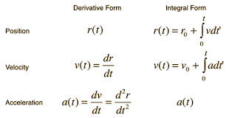

If these symbols look really confusing to you, don’t worry, they were confusing to me at first too. Basically this is saying the same things I said before (velocity is the rate of change of the position with respect to time). We can also see that acceleration is the rate of change of the velocity with respect to time. The rate of change is denoted by derivatives, which is the dr/dt and the other one. What the right column is saying is the same thing but showing it backwards. Just as velocity is the rate of change of the position, position is also the integral (or antiderivative) of velocity. Adding on, velocity is the integral of acceleration. To find a new position of an object using vectors, we need to calculate the displacement.

Displacement is a vector quantity that describes the change in position of an object. It is calculated by subtracting the initial position vector from the final position vector. But to find this change, we need to use the velocity vector.

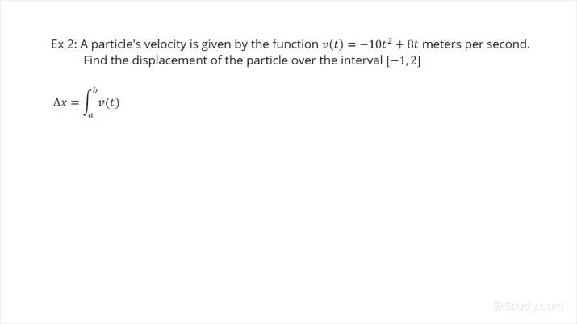

Here is the formula for the displacement. Note that this is the formula for the change of x. Remember the vectors that we used have 2 values, an x and y. To find the change in y we just need to integrate the y quantity of the velocity vector.

Now, once you find the displacement, we simply add it to the original position to calculate the new position.

Keep in mind that our program is a little dumbed down so there is no advanced calculation like this happening, but it is important to understand the topic of why the position changes. Now let’s get back on track to understanding the code.

keys = pygame.key.get_pressed()

if keys[pygame.K_UP]:

vel += pygame.math.Vector2(0, -acceleration)

if keys[pygame.K_DOWN]:

vel += pygame.math.Vector2(0, acceleration)

if keys[pygame.K_LEFT]:

vel += pygame.math.Vector2(-acceleration, 0)

if keys[pygame.K_RIGHT]:

vel += pygame.math.Vector2(acceleration, 0)

What this code is saying is that when you press a certain key, in this case the arrow keys, the velocity vector changes by the amount of the acceleration. So when we press the up key we add the negative amount of acceleration to move it up. But wait, are you confused why we add the negative amount to move it upwards and not downwards? I was also puzzled by this at first because it seems like it would be correct for a negative amount to move down instead of up. It turns out this is because I was so used to the cartesian coordinate system. Let me explain using pictures.

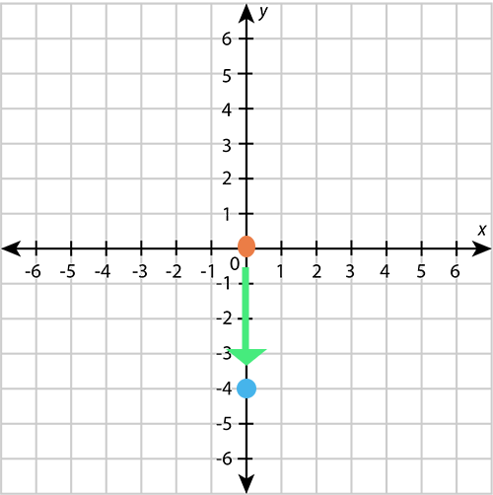

Here you can see our Cartesian plane that we all know and love. I also plotted some points to visualize what I was thinking when I first wrote the code solution. The orange dot can represent our object at the starting position (0,0). The blue dot represents the dot after moving it by the negative amount of acceleration that was added. The green arrow shows the movement of the object going down. This all makes sense in my brain, but this is not how it works in the program. In the program, the circle moves up when we add a negative amount of acceleration. Why is this?

This happens because of how the axes work in pygame and in computers in general. Let’s see a picture to better understand.

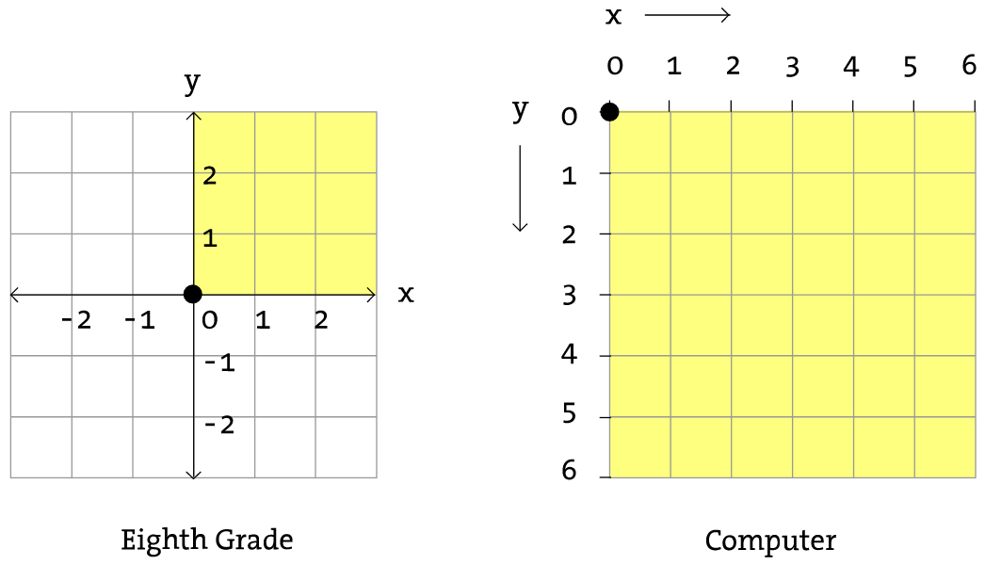

The coordinate system used in computers typically refers to the pixel coordinate system used to display graphics on a screen, whereas the Cartesian coordinate system, or Eighth Grade System, refers to a mathematical system used to represent points in a plane or space. In the pixel coordinate system used in computers, the screen is divided into a grid of small units called pixels. Each pixel is assigned a unique location on the screen represented by a pair of coordinates (x,y), where x represents the horizontal position and y represents the vertical position. The origin (0,0) is typically located at the top left corner of the screen, with x increasing to the right and y increasing downwards. On the other hand, the Cartesian coordinate system represents points in a plane or space using a pair or triplet of numerical values (x,y) or (x,y,z), respectively. The origin (0,0) in a Cartesian coordinate system is typically located at the center of the coordinate system, with the x-axis extending horizontally to the right and left, the y-axis extending vertically up and down, and the z-axis extending perpendicularly to the x and y axes. While both coordinate systems use pairs of numerical values to represent locations, the way in which those values are assigned and the orientation of the axes are different between the two systems.

This can explain the acceleration values and why they have to be negative for it to move up. I will provide a visualization for easier understanding.

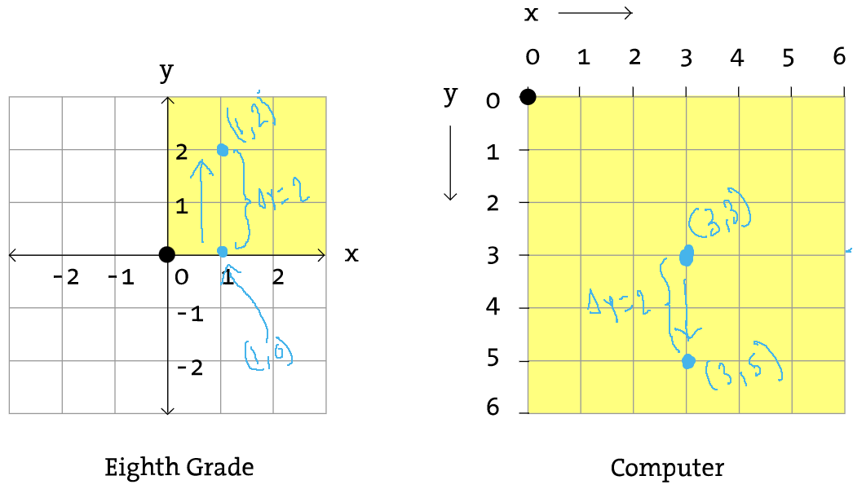

Here is my attempt to show the difference between the Cartesian system and the Computer system. As you can see. The dot moves from (1,0) to (1,2) on the cartesian system, which gives the change of y position at positive 2. Notice in the Computer system, the dot moves from (3,3) to (3,5), which is also a change of y position of positive 2. But look at the direction the arrow is pointing. The dot is moving downwards. This is because the y axis increments as it going downwards, opposed to the cartesian system where it increments as it's going upwards, hence giving the object opposite direction of movement with the change of y.

if keys[pygame.K_DOWN]:

vel += pygame.math.Vector2(0, acceleration)

This code can be explained by the graph above. This is saying when we press the down arrow key, the velocity vector’s y value is changed to the acceleration value, which is positive by default. When we add a positive number to the y position, the object in our game moves down.

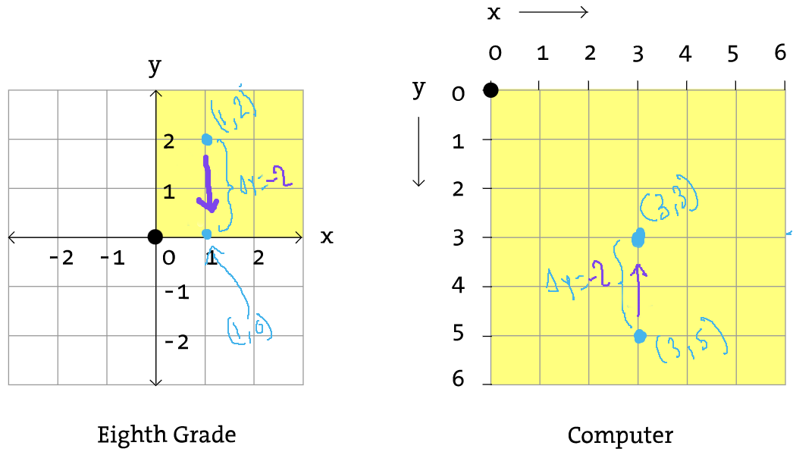

This new graph is showing the opposite of what the graph on the page before is showing. When we swap the starting position of the dot, the change of y position switches from positive to negative 2, which makes sense. You can see now that when the change of y is negative, the arrow is pointing upwards on the computer axis system. This explains the negative values that we used to move the object upwards in our game.

if keys[pygame.K_UP]:

vel += pygame.math.Vector2(0, -acceleration)

This code says that when you press the up arrow key, the y value of the velocity vector is replaced with the negative value of acceleration. This makes sense because if you visualize it, the object would move up since we are subtracting from the y value on the position vector, which will move the object upwards in our game.

Now that we understand how the movement works and all the math behind it, let’s move on to something new.

**Introduction to MatPlotLib**

Matplotlib is a powerful and widely-used plotting library for the Python programming language. It provides a variety of tools for creating high-quality, publication-ready visualizations of data in a range of formats, including line plots, scatter plots, histograms, and more. Matplotlib is highly customizable and allows users to fine-tune every aspect of their plots, from the colors and line styles to the fonts and axes labels. One of the great strengths of Matplotlib is its versatility, as it can be used in a wide variety of settings, from data analysis and scientific research to data visualization and presentation. Its simple and intuitive syntax makes it accessible to users of all skill levels, from beginners to advanced programmers. With Matplotlib, users can easily generate complex and interactive plots that enable them to explore and communicate their data with clarity and precision. Whether you're working with small datasets or large-scale data analysis projects, Matplotlib is an indispensable tool for anyone looking to visualize their data in a meaningful and effective way.

There are 2 different ways to use the matplotlib library. One way is to import MatPlotLib to your environment. You first have to install the library to your environment using the **pip install matplotlib** command. Another way, which is easier and the one I am going to use is Google Colab. Essentially, Google Colab is a jupyter notebook in the browser. To get started with colab, go to [google colab](https://colab.research.google.com) and create a new notebook. Here, you do not need to worry about installing any libraries.

Great, now we are ready to get started.

**Basic Plotting**

As we know, matplotlib is used to visualize data, so let’s jump right into it.

First we need to import our desired library.

import matplotlib.pyplot as plt

Before we get into plotting, we need to understand what we are trying to do. For our basic plot, we will be graphing simple data. This will be done on the cartesian plane, remember that picture from before? This will be done in the first quadrant, and how we do it is pretty easy. First, we need to have some data to plot which will be provided below this.

# Median Developer Salaries by Age

dev_x = [25, 26, 27, 28, 29, 30, 31, 32, 33, 34, 35]

dev_y = [38496, 42000, 46752, 49320, 53200,

56000, 62316, 64928, 67317, 68748, 73752]

This is our sample data. The dev_x will be the ages for developers, and dev_y will be their salaries. As you can guess, the dev_x data will be plotted on the x axis and the dev_y will be plotted on the y axis. To do this we have to use the function below.

plt.plot(dev_x, dev_y)

If you are doing this on your local machine and not in colab, then you need this extra line.

plt.show()

The plot function above takes both of the lists as arguments. This first argument is our x axis and the second will be the y axis.

This is what the plot should look like.

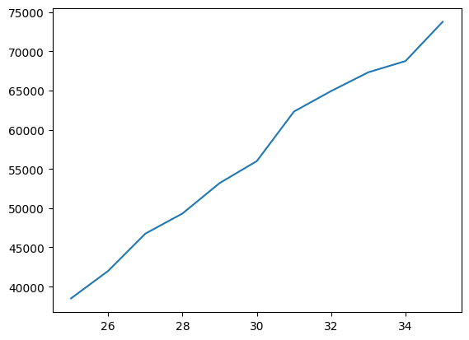

Now, we know what this plot represents because we can see the data ourselves, but what if we wanted to present this to someone else? This graph would make sense to anyone without any description, so let’s add some labels to make it easier to read.

plt.title("Median Salary of developers by age")

plt.xlabel("Ages")

plt.ylabel("Salaries")

If you are on a local machine, put this before the plt.show(), else, just put it after plt.plot().

The code is pretty self explanatory, but this code gives the title to the graph, as well as the x and y labels. This is what the new graph should look like.

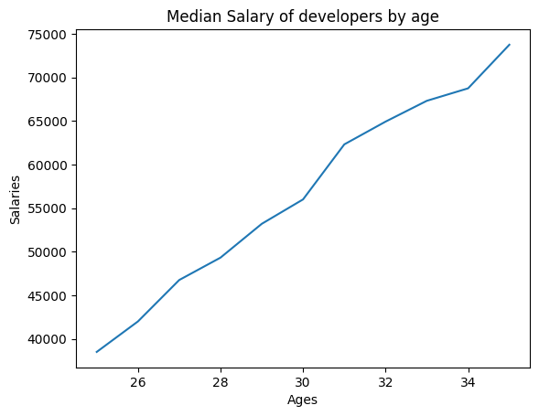

This graph is much more descriptive than the other one right?

**Adding more data**

Now that we know how to do a basic plot of data, we can add more data to our plot.

# Median Python Developer Salaries by Age

py_dev_x = [25, 26, 27, 28, 29, 30, 31, 32, 33, 34, 35]

py_dev_y = [45372, 48876, 53850, 57287, 63016,

65998, 70003, 70000, 71496, 75370, 83640]

This is our new data. Now let’s plot this on our graph.

plt.plot(py_dev_x, py_dev_y)

This is what our new graph looks like.

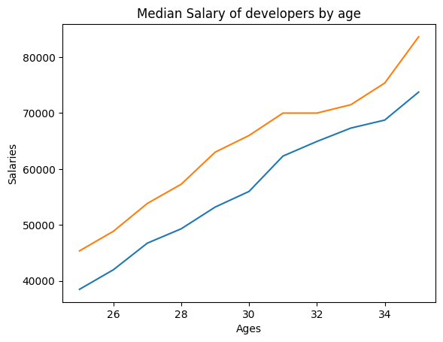

Again, this graph is not descriptive enough for a reader because he does not have the data to look at. To make it more descriptive, let’s add a legend to differentiate between the lines on the graph. To do this, use the simple code provided below.

plt.legend(['All devs', 'Python devs'])

This code is also pretty simple, but it takes a list as an argument and it will match the color of the line on the plot by the order of the list, so make sure to order the list argument correctly to match your graph. This is what the graph should look like after this.

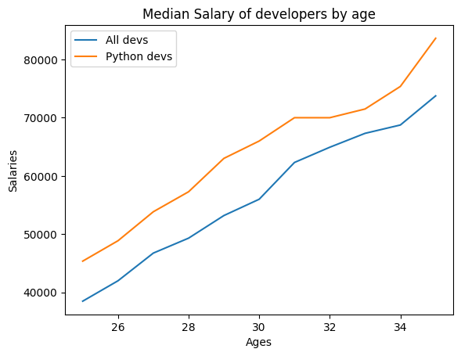

As you can see, this graph is much easier to read with the legend. Let’s analyze this data so we can understand what it is saying. We see on the plot that there are 2 lines, one being for all developers and one being python developers. What generalization can we make from the visualization above? Well, I think we can generalize that developers who specialize in python have a higher income than developers who do not specialize. Why can we say this? This is because the orange line is above the blue line for all x on the graph. What we just did is go through an example of how data analyzers do their job. Though it is a very simple example, we did the fundamentals: ask a question, visualize the data, and answer the question. These 3 steps are used to do most problems in the field of data analytics.

**Draw Function**

The draw() function is a method in Matplotlib that is used to update the plot with any changes that have been made. When you create a plot in Matplotlib, it is not immediately displayed until you call show() or draw() to render it. The show() function displays the plot in a new window and keeps the window open until you close it, while draw() updates the existing plot in the current window. The draw() function is often called automatically when you make changes to the plot using other Matplotlib methods, such as plot(), scatter(), text(), etc. However, in some cases you may need to call draw() explicitly to update the plot after making changes, such as modifying the properties of an existing object or adding new objects to the plot. It's important to note that draw() can be computationally expensive for large or complex plots, as it redraws the entire plot each time it is called. Therefore, it's generally recommended to only call draw() when necessary, and to use other Matplotlib methods, such as set_data(), set_color(), etc., to modify existing objects whenever possible, rather than creating new ones. But in our case, we need this function for our next coding problem so we will be learning how to use it. Let’s dive straight into an example. Keep in mind from now on, you can not use google colab and I would recommend switching to PyCharm. The download link can be found here: [Download PyCharm Link](https://www.jetbrains.com/pycharm/download/#section=windows)

Let’s start by importing the libraries that we need.

import matplotlib.pyplot as plt

For this example we will be using the draw function to move the circle to where we click on the plot and redraw it at the position of the click. Let’s start by declaring the circle’s properties.

x0, y0 = 0.5, 0.5

radius = 0.1

Next, we can create our function to draw the initial circle

def draw_circle():

global circle

circle = plt.Circle((x0, y0), radius, color='blue')

ax.add_artist(circle)

Notice that we need to make the circle a global variable to use for later. Drawing a circle is pretty simple as we can use matplotlib’s built-in **circle class that takes the initial, position, radius, and color to form the circle**. The add_artist() function is a method in Matplotlib that is used to add an artist object to the plot. In Matplotlib, an artist is a basic visual element that can be added to the plot, such as a line, text, image, or patch. When you create an artist object, it is not automatically added to the plot. Instead, you need to call the add_artist() method and pass the artist object as an argument to add it to the plot. Once the artist is added to the plot, you can modify its properties using other Matplotlib methods. The **add_artist() function is often used to add complex shapes or polygons to the plot, such as circles, rectangles, or polygons**, which can be created using the Circle(), Rectangle(), or Polygon() classes in Matplotlib. These shapes are not created using the plot() function, which is used to create simple lines or scatter plots, but rather using the appropriate Matplotlib artist classes and then adding them to the plot using add_artist().

At this point we can plot our initial circle on the graph to test it.

fig, ax = plt.subplots()

draw_circle()

# Set the plot limits and show the plot

ax.set_xlim(0, 10)

ax.set_ylim(0, 10)

plt.show()

The plt.subplots() function is a method in Matplotlib that is used to create a figure and one or more subplots. In Matplotlib, a figure is the overall window or container that contains one or more subplots, while a **subplot is a smaller plot within the larger figure**. The subplots() function is a convenient way to create a figure and one or more subplots in a single line of code. The subplots() function returns two values: **a Figure object and an array of Axes objects (fig and ax)**. The Figure object is the overall container for the plot, while the Axes objects are the individual subplots within the figure. The Axes objects can be used to customize the properties of each subplot, such as setting the x- and y-axis limits, adding titles or labels, etc. The plt.subplots() function is useful because it simplifies the process of creating multiple subplots in a single figure, and ensures that the subplots are properly aligned and spaced. Additionally, it returns the Figure and Axes objects, which can be used to further customize the plot as needed.

The ax.ser_xlim and ax.set_ylim just set the x and y values on the plot. In this case, the graph would start with 0 as the x and y and go up to 10 for both axes. The finished graph should look like this.

On the next page ---------------------->

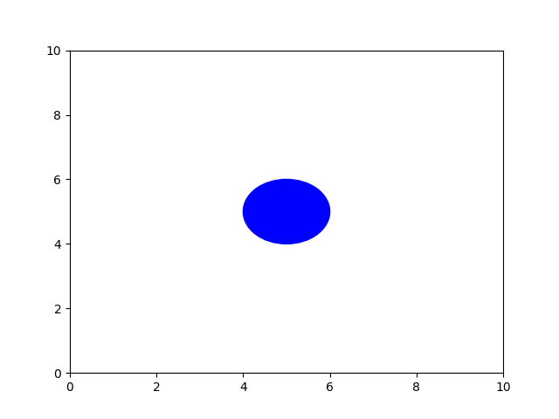

As we can see we have a blue circle in the middle of the graph just as we expected. But we want this circle to move with our mouse click to showcase the use of the draw function, so let’s add a new function for this.

# Define a function to update the circle's position

def update_circle(event):

global x0, y0, circle

if event.button == 1:

x0, y0 = event.xdata, event.ydata

circle.center = x0, y0

plt.draw()

This function is called every time a mouse button is pressed within the plot. It takes an event object as an argument, which contains information about the button press. The global keyword is used to indicate that the variables x0, y0, and circle are defined in the global scope (i.e. outside of the function). The function first checks if the left mouse button was pressed (event.button == 1). If so, it sets the variables x0 and y0 to the x and y coordinates of the mouse click (event.xdata and event.ydata, respectively). It then updates the center attribute of the circle object to the new coordinates (circle.center = x0, y0), and redraws the plot (plt.draw()).

To use the function we just created, we need to call it using a special matplotlib method

fig.canvas.mpl_connect('button_press_event', update_circle)

fig.canvas.mpl_connect() is a Matplotlib method that connects an event to a function, allowing the function to be called whenever that event occurs within the figure canvas. In this case, the event being connected is the button_press_event, which occurs whenever a mouse button is pressed within the figure canvas. The first argument of fig.canvas.mpl_connect() specifies the event to be connected, in this case 'button_press_event'. The second argument is the function that should be called whenever that event occurs, in this case update_circle. So the line fig.canvas.mpl_connect('button_press_event', update_circle) is connecting the button_press_event to the update_circle function. Whenever the user clicks the mouse button within the figure canvas, the update_circle function will be called and passed an event object that contains information about the button press, such as the x and y coordinates of the mouse click. This allows the update_circle function to respond to mouse clicks and update the position of the circle in the plot accordingly.

In summary, this code creates a Matplotlib plot with a blue circle centered at (5,5) with a radius of 1. The circle can be moved by clicking and dragging it to a new location using the mouse. The function draw_circle() is used to create and draw the circle on the plot, while update_circle() updates the position of the circle when the mouse is clicked and dragged. The fig.canvas.mpl_connect() function is used to connect the mouse click event to the update_circle() function. Finally, the ax.set_xlim() and ax.set_ylim() functions set the limits of the x and y axes respectively.

The live demonstration to view the end result of the code can be found here:

[Draw Function Example Python Matplotlib](https://youtu.be/cPCKLHyk-NY)

We need to call this function after our initial draw function so we won’t get any errors. The finished code should look like this:

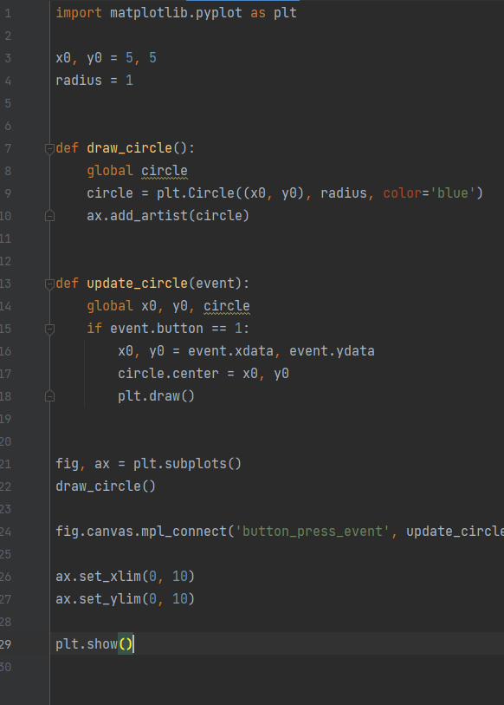

**Intro to OpenCV**

In today's digital age, images and videos play a vital role in numerous fields, ranging from computer vision and robotics to healthcare and entertainment. To analyze, process, and manipulate these visual data, developers and researchers rely on powerful tools and libraries. One such indispensable library is OpenCV (Open Source Computer Vision Library), a versatile and widely used open-source computer vision and machine learning software library. In this chapter, I will introduce you to the OpenCV library and its integration with Python, providing a comprehensive foundation for understanding and utilizing its capabilities. OpenCV was initially developed by Intel in 1999, and since then, it has evolved into a community-driven project, encompassing a vast array of computer vision algorithms and functions. OpenCV is renowned for its efficiency, flexibility, and accessibility, making it a go-to solution for both beginners and experts alike. Its ability to process real-time images and videos in real-world applications is truly remarkable. With OpenCV, you can perform a multitude of tasks, including image and video capture, image filtering and enhancement, object detection and tracking, facial recognition, and much more. In this chapter, we will delve into the fundamentals of OpenCV, focusing on its Python interface, which provides a user-friendly environment for experimenting with computer vision algorithms. We will cover key concepts such as image representation, basic image operations, and essential techniques like edge detection and image transformation. To get started, you'll need to have OpenCV installed on your system. I will walk you through the installation process and ensure you have everything set up correctly. We'll then dive into the core functionalities of OpenCV, exploring various image processing techniques step by step. Throughout this chapter, I will present practical examples and exercises to reinforce your understanding and allow you to apply what you've learned. By the end, you'll have a solid understanding of the OpenCV library and we will be creating our own facial recognition program plus more!

**Installation**

For OpenCV, I recommend using PyCharm as you should have it installed already from the previous chapter. PyCharm makes it very easy to install the library without any issues. Let’s start by creating a new file and install the library through the Python Packages tab on the bar seen below.



Then we can look up opencv in the packages search bar.

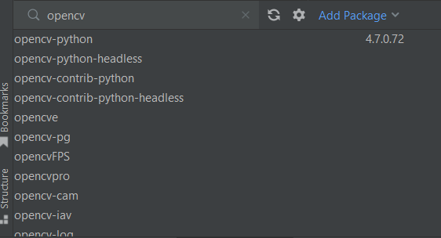

Choose the one that says opencv-python and press install.

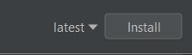

You can check for the installed package in the installed tab.

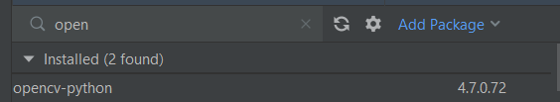

Perfect! Now we can start coding.

Let’s start by importing the library.



In this book, we will specifically be focusing on object detection, specifically face detection. There is this amazing pre-trained file with all of the classifiers that we need for our purposes.

face_cascade = cv2.CascadeClassifier(cv2.data.haarcascades + 'haarcascade_frontalface_default.xml')

The XML file 'haarcascade_frontalface_default.xml' contains the pre-trained model for face detection using Haar-like features. The model is trained using the Haar cascade algorithm, which is a machine learning approach for object detection. The Haar cascade algorithm works by applying a series of rectangular filters to an image and analyzing the differences in pixel intensities within these regions. These rectangular filters are known as Haar-like features. The algorithm uses a set of positive and negative training images to learn the features that best represent the object being detected (in this case, faces) and distinguish them from the background. The training process involves repeatedly adjusting the weights and thresholds of these Haar-like features to minimize the classification error. The result is a set of classifiers that can efficiently detect objects of interest in new unseen images. The XML file that we imported specifically contains the trained model for detecting frontal faces. It is a cascading classifier, which means it consists of multiple stages, each with multiple weak classifiers. These weak classifiers are combined to form strong classifiers that can accurately detect faces under various conditions. When the XML file is loaded using cv2.CascadeClassifier, it initializes a CascadeClassifier object with the pre-trained face detection model. This object can then be used to perform face detection on images or video frames using the detectMultiScale method, which applies the cascade of classifiers to identify regions in the image that likely contain faces. We will cover the cascade classifier in depth at the end, so do not worry if you do not completely understand.

For our basic face detector, let’s use the haar classifiers to detect Rick Astley's face in the famous picture.

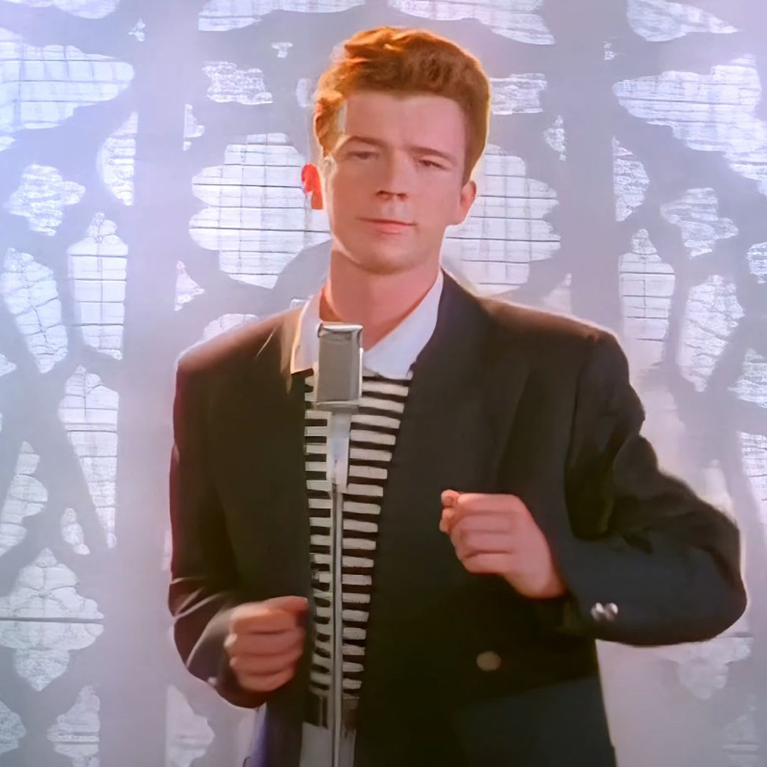

We are going to use OpenCv to detect and label Rick Astley's face in this picture. To start we need to read the image into the python file. Before we code anything, we need to download the picture first, so take a minute and download this picture from this google. Then drag the file into the folder on PyCharm. Now let’s start to code.

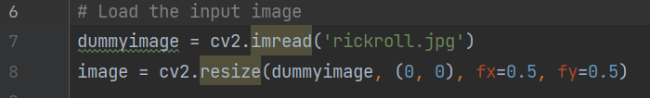

In my folder, the image is named rickroll.jpg, but feel free to name your image whatever you want.

dummyimage = cv2.imread('rickroll.jpg'): It reads an image file named 'rickroll.jpg' using the cv2.imread() function and assigns it to the variable dummyimage. The cv2.imread() function reads the image file from the specified path and returns a NumPy array representing the image.

image = cv2.resize(dummyimage, (0, 0), fx=0.5, fy=0.5): It resizes the dummyimage using the cv2.resize() function and assigns the result to the variable image. The cv2.resize() function is used to resize an image to the specified dimensions. In this case, the function scales the dummyimage by a factor of 0.5 in both the horizontal (fx) and vertical (fy) directions. The (0, 0) parameter indicates that the output size should be calculated based on the scale factors provided.

This next part of our code is a little confusing.

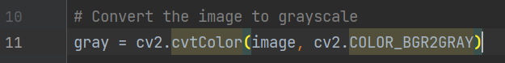

This code segment performs the conversion of an image from color (BGR) to grayscale using OpenCV's cv2.cvtColor() function. When it comes to face detection, converting an image to grayscale is a common practice for a few important reasons. First, grayscale images have a simpler representation compared to color images. They use only shades of gray to represent the intensity of each pixel, removing the complexity of color variations. This simplification makes it easier for face detection algorithms to focus on the structural features and patterns of faces, such as edges, shapes, and textures. Second, converting an image to grayscale reduces the dimensionality of the data, making the face detection process more efficient. Grayscale images have just one channel instead of three channels (red, green, and blue) in color images. This reduction in dimensionality speeds up the computations and saves memory, which is especially useful when working with large datasets or real-time applications. Furthermore, grayscale conversion enhances the robustness of face detection algorithms. By removing color information, grayscale images are less sensitive to variations in skin tones and lighting conditions. This means that the face detection algorithm can perform consistently across different individuals and environments, leading to improved accuracy. In summary, converting an image to grayscale simplifies the representation, reduces computational requirements, and improves the performance of face detection algorithms. It allows the algorithms to focus on the essential structural features of faces, makes them more efficient, and enhances their ability to handle variations in skin tones and lighting conditions.

The next thing we do is actually perform face detection.



This code segment is responsible for performing the face detection using the detectMultiScale() function from OpenCV's CascadeClassifier class. The detectMultiScale() function analyzes the grayscale image (gray) and attempts to detect faces based on the parameters provided. It returns a list of rectangles representing the detected faces, where each rectangle is defined by its (x, y) coordinates (top-left corner) and its width and height (w, h). By adjusting the scaleFactor, minNeighbors, and minSize parameters, you can control the sensitivity, accuracy, and size constraints of the face detection algorithm to suit your specific requirements. The faces variable will contain the list of rectangles representing the detected faces, allowing you to further process or manipulate them as needed in the subsequent steps of your application.

Here are the parameters explained in-depth if you want to understand it better:

The scaleFactor parameter in the detectMultiScale() function controls the scale at which the image is resized during the face detection process. It plays a crucial role in determining the size of the image pyramid, which is a multi-scale representation of the image used to detect objects at different sizes. The purpose of the image pyramid is to handle faces of varying sizes in the input image. Faces closer to the camera will appear larger, while faces farther away will appear smaller. By rescaling the image at different scales, the algorithm can effectively detect faces of different sizes. The scaleFactor value determines the amount of scale reduction applied at each step of the image pyramid. For example, if scaleFactor is set to 1.1, it means the image is progressively scaled down by 10% at each iteration. This reduction allows the algorithm to search for faces at different scales, from large to small. A smaller scaleFactor, such as 1.1, leads to a larger number of image scales in the pyramid, making the algorithm more sensitive to smaller faces. However, it also increases the computational complexity because more scales need to be processed. On the other hand, a larger scaleFactor, such as 1.5, decreases the number of scales, making the algorithm less sensitive to small faces but faster. Choosing an appropriate scaleFactor depends on the specific application and the expected size range of the faces you want to detect. It's a trade-off between sensitivity, accuracy, and computational efficiency. In practice, it often requires experimentation and fine-tuning to find the optimal value for a given scenario.

The minNeighbors parameter in the detectMultiScale() function is used to control the quality of face detection by specifying the minimum number of neighboring rectangles required to consider a detection as valid. During the face detection process, the algorithm scans the image at multiple scales and identifies potential face regions. However, some of these detections may be false positives or noise. To filter out such false detections and increase the reliability of the results, the minNeighbors parameter is employed. The minNeighbors value represents the minimum number of neighboring rectangles that need to overlap with a particular detection in order for it to be considered a valid face. These neighboring rectangles are obtained during the detection process, and they represent nearby regions that share similar characteristics with the potential face region. By requiring a certain number of neighbors to support a detection, the algorithm can eliminate isolated or spurious detections that do not exhibit consistent face-like properties. The minNeighbors value acts as a threshold or constraint to filter out such false positives. A higher minNeighbors value results in stricter filtering and reduces the chances of false detections. However, it may also lead to missing some valid face detections, especially in crowded scenes or when faces are partially occluded. On the other hand, a lower minNeighbors value allows for more potential detections but also increases the likelihood of false positives. The appropriate choice of minNeighbors depends on the specific application, desired trade-off between sensitivity and precision, and the characteristics of the input images. It often requires experimentation and fine-tuning to determine the optimal value for a given scenario.

The minSize parameter in the detectMultiScale() function is used to specify the minimum size of the detected objects, in this case, faces. It determines the smallest size of the face that the algorithm should consider during the detection process. When performing face detection, the algorithm searches for faces at different scales within the image pyramid. However, it may not be desirable to detect very small or tiny faces, as they might be irrelevant or less reliable for the given application. By setting the minSize parameter, you can control the lower limit on the size of the detected faces. Only the faces whose dimensions (width and height) exceed or equal to the specified minSize are considered as valid detections. For example, if you set minSize = (100, 100), it means that the algorithm will ignore any detected regions that have a width or height smaller than 100 pixels. It allows you to filter out smaller regions that are not likely to correspond to actual faces. The purpose of using minSize is to avoid detecting small objects or noise that may appear in the image but are not relevant to the intended application. It helps to improve the robustness and specificity of the face detection algorithm by enforcing a minimum face size threshold.

If you remember from before, the detectMultiScale method returns a x, y, w, and h which represent our coordinates and the dimensions of the rectangle for our face. But this is only in memory. To see our rectangles we have to tell the computer to draw them for us.



In the given code, a loop is used to process each detected face stored in the faces variable, which contains the information about the bounding boxes of the detected faces. The loop iterates over each face and extracts the coordinates and dimensions of the bounding box: x, y, w, and h. The cv2.rectangle() function is then used to draw a rectangle around each face on the image. This function takes several arguments to define the rectangle: the image itself, the coordinates of the top-left corner (x, y), the coordinates of the bottom-right corner (x + w, y + h), the color of the rectangle (in this case, green), and the thickness of the rectangle's lines. By executing this loop for each detected face, a rectangle is drawn around each face on the image. This visual representation helps to highlight and mark the locations of the detected faces, making it easier to identify and analyze them within the image.

Just to add more description, let’s add some text. The finished loop should look like this.

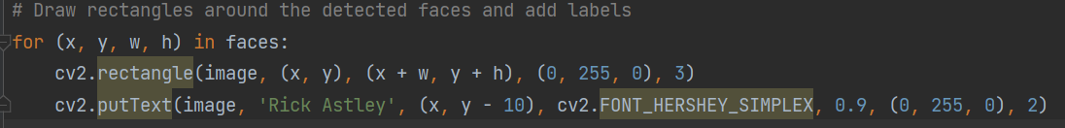

The putText method is pretty self explanatory, but it essentially puts text on the screen. The first parameter, image, represents the image on which the text will be placed. The second parameter, 'Rick Astley', is the actual text that will be displayed on the image. The next parameter, (x, y - 10), specifies the coordinates where the text will be positioned. The (x, y) values represent the starting point of the text, and y - 10 shifts the text slightly above that point to avoid overlapping with the content below. The fourth parameter, cv2.FONT_HERSHEY_SIMPLEX, determines the font style to be used for the text. In this case, it uses the FONT_HERSHEY_SIMPLEX font style, which is a simple and readable font. The fifth parameter, 0.9, sets the font scale, determining the size of the text relative to the image. A value of 0.9 means that the text will be 90% of the default size. The sixth parameter, (0, 255, 0), specifies the color of the text. In this case, it uses the RGB color format, with (0, 255, 0) representing a bright green color to match our face rectangles.

Our final step is to actually show the image that we imported in the opencv window.

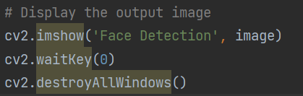

The first line, cv2.imshow('Face Detection', image), creates a window with the title 'Face Detection' and displays the specified image within that window. The image variable represents the image data to be shown. This function allows you to visually inspect the image or the results of any image processing operations. The second line, cv2.waitKey(0), is used to wait for a keyboard event. The parameter 0 indicates that the program will pause and wait until any key is pressed. This is useful for keeping the image window open until the user decides to close it. The third line, cv2.destroyAllWindows(), is responsible for closing all OpenCV windows created by the program. It ensures that any remaining windows are closed and the program terminates gracefully. Together, these lines of code display an image in a window, pause the program until a key is pressed, and then close the image window when the user is finished interacting with it.

Let’s see what our image looks like now. Keep in mind we probably have different images, so it might differ a little, but it essentially should look the same.

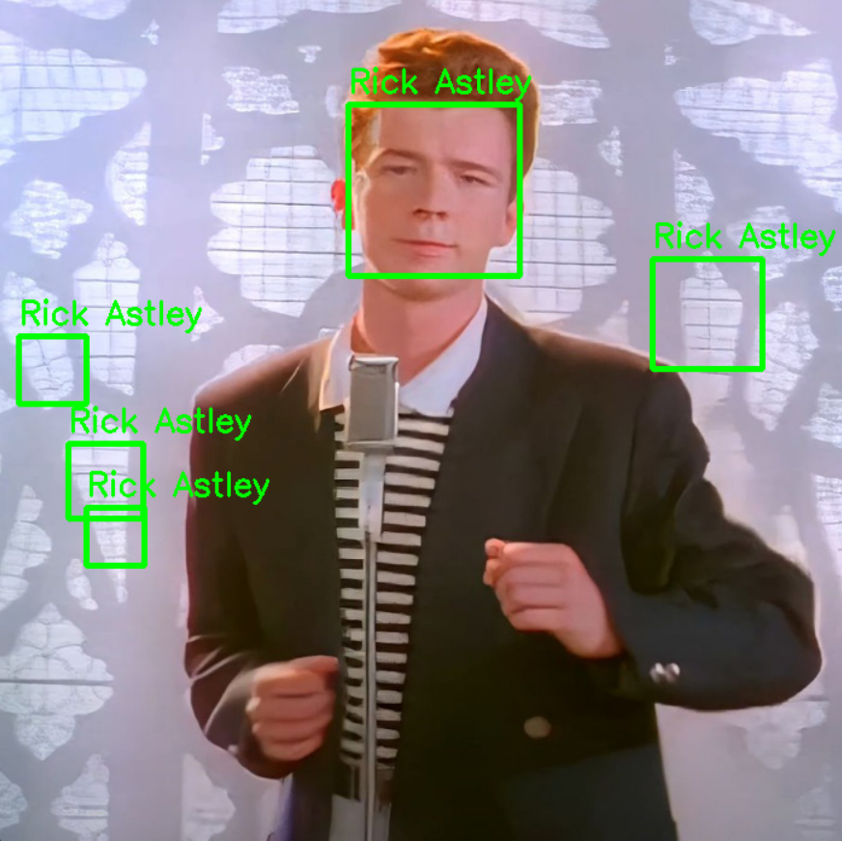

Oh no! What happened? Let’s take a look at our finished code.

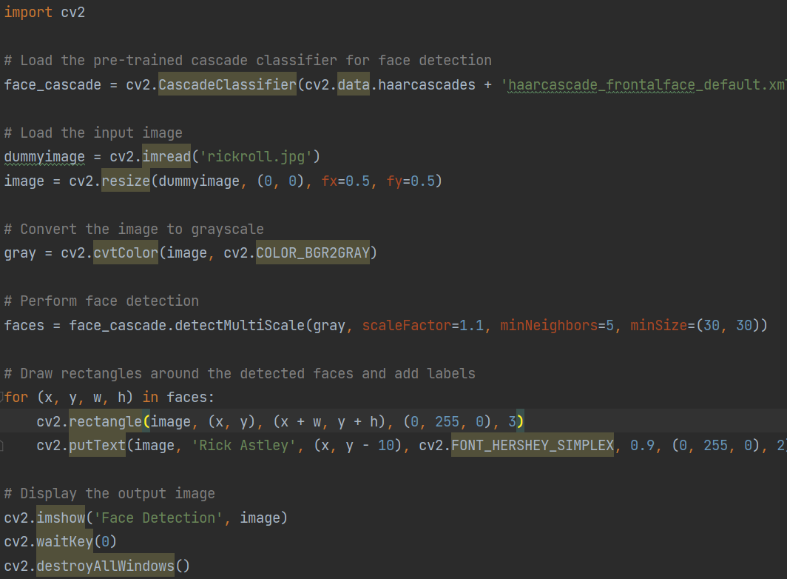

Can you spot what might create these small incorrect detections? If you guessed the minSize, you would be correct. Let’s try making these values greater to eliminate the excess rectangles.

With (70,70)

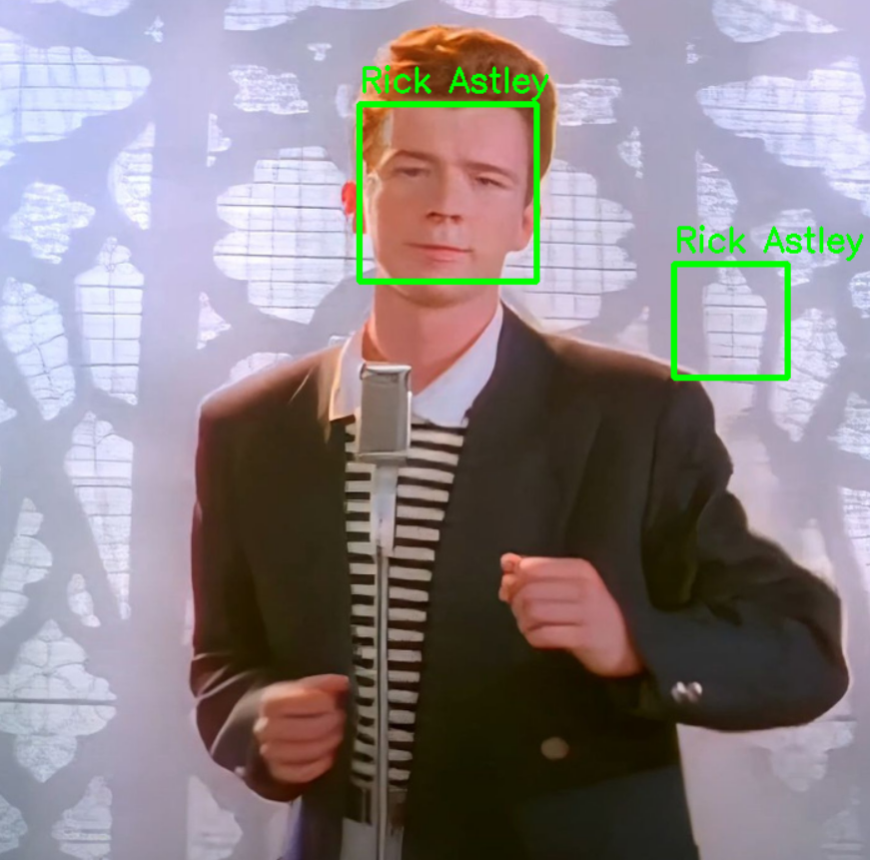

Close! Let’s try increasing it a little more.

With (100,100)

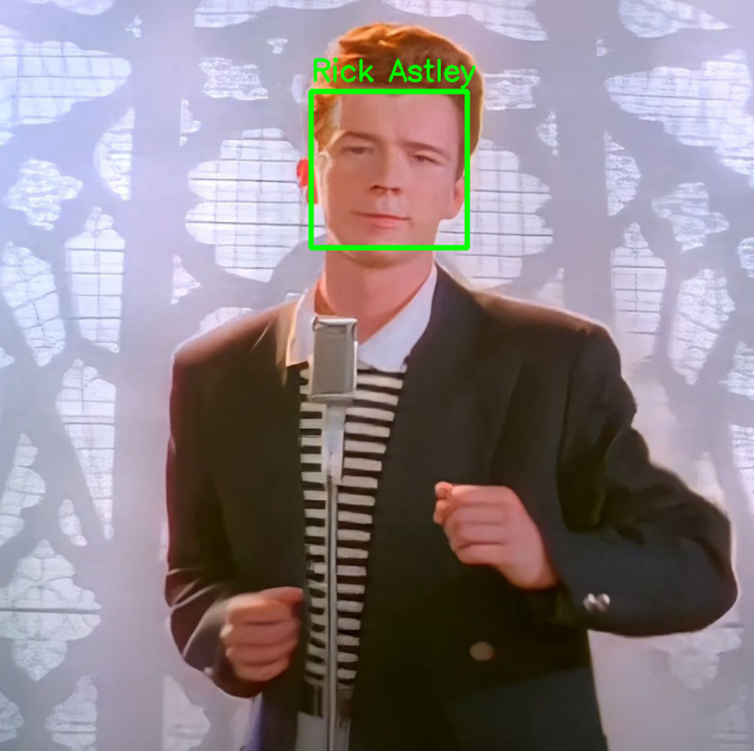

Perfect! We just created a program that can detect the face of Rick Astley, or really just anyone. **Activity**: Try our script on different images. You might have to play around with the code for some images for it to detect correctly. I will also provide some examples below.

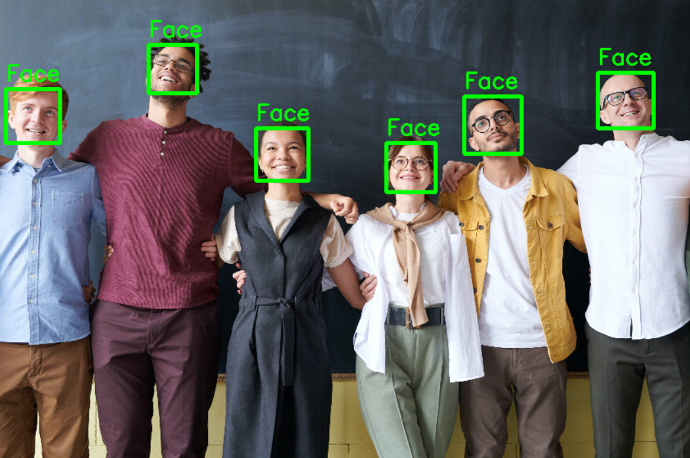

Here is an example with a group of people. With just some changes to the code, we can easily detect multiple faces in any image.

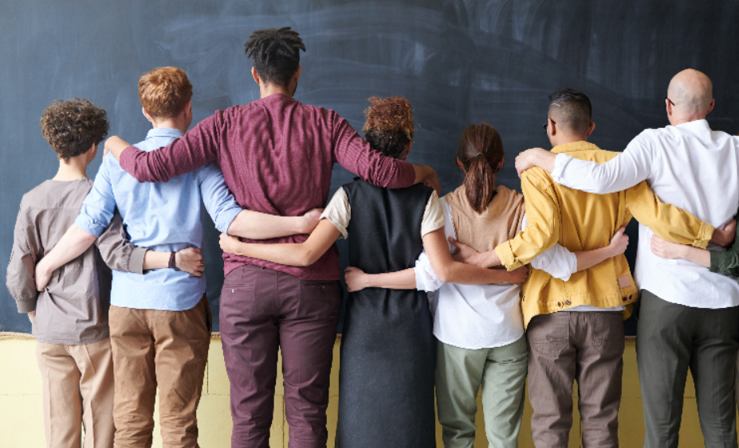

I just wanted to remind everyone reading that this xml file only works to detect frontal faces. This is the same image from above, except that it is backwards. This also applies to tilted faces and such, just so you are not frustrated if no changes in the code are not detecting anything.

**Code for examples above**

Here is the changed code to detect the images above.

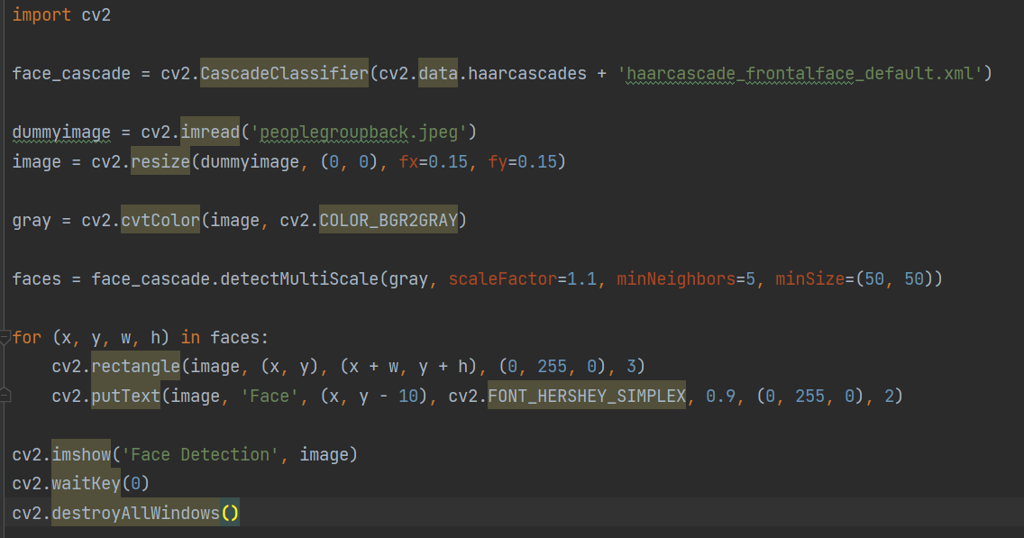

The changes made to the original are the image resize parameters because the image that I chose was apparently very big, so I put it at 15 percent of the original size. I also changed the minSize property because if you notice, the faces in the picture above are smaller relative to the Rick Astley Picture that we used before. (50,50) seemed to get everyone's face detected. Also note that the new image has a relatively clear background, which makes it easier to make everything detected. Why do you think when you get your driver's license or other government photos taken, they make you take it with a clear background with no smile. This is so the algorithms to detect faces have a much easier time to deal with detecting those faces than those with messy backgrounds.

Here are the specific changes made.



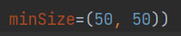

**Detection on a video**

Within the realm of computer vision, the process of face detection encounters subtle differentiations when transitioning from static images to the realm of moving videos. The nuances that arise in video analysis require a modest but notable shift in the approach to identifying faces. When examining a single image, the conventional face detection algorithms utilize intricate techniques to meticulously scrutinize each pixel. By analyzing the grayscale representation of the image, these algorithms seek specific facial features such as eyes, noses, and mouths. Employing a cascade of classifiers, they diligently detect and delineate facial contours, considering variations in shape, size, and texture. However, the venture into video introduces an altered landscape, necessitating a refined perspective. Video frames encapsulate a temporal dimension, representing a continuous stream of images. Consequently, face detection in videos demands the ability to track and recognize faces as they traverse across frames, capturing the fluid expressions and movements that animate the human countenance.

A lot of the steps are basically the same for images and videos, but there are some differences which will be shown and explained. First let’s start by importing the library.

Before we start anything, we have to have a video to test on. Later, we will be learning something fun to do this, but for now, I will provide a sample video: [Video Link](https://github.com/intel-iot-devkit/sample-videos/blob/master/head-pose-face-detection-female-and-male.mp4)



We will be using the same pre-trained classifier from before.

face_cascade = cv2.CascadeClassifier(cv2.data.haarcascades + 'haarcascade_frontalface_default.xml')

Our first change comes here.



To tell the library to read a video, we have to specify it by using the built-in VideoCapture function. In my file, I just kept the default video name, but feel free to change that.

Now we can start our main logic for the detection.

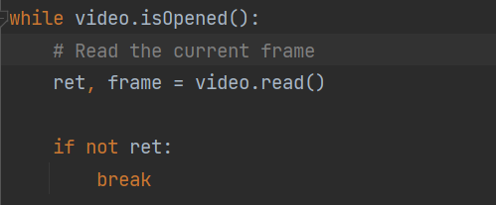

As you can see, this is different from what we used before to detect images. The while loop is necessary for performing face detection on a video because it allows us to process each frame of the video sequentially. Let me explain. If you think about it, a video is really just a lot of pictures that are next to each other. We can call each image in a video a frame, which is automatically done by the video.read(). This while loop is going to iterate through all the frames in the video and perform face detection on each one. Once it is combined, it's in motion, hence a video. The if not ret tells the program to end when it can not read a frame from the video anymore, which means it is at the end of the video. When this happens, it breaks out of the while loop to perform any actions outside of the while loop.

The next steps are essentially the same as the steps for the image.

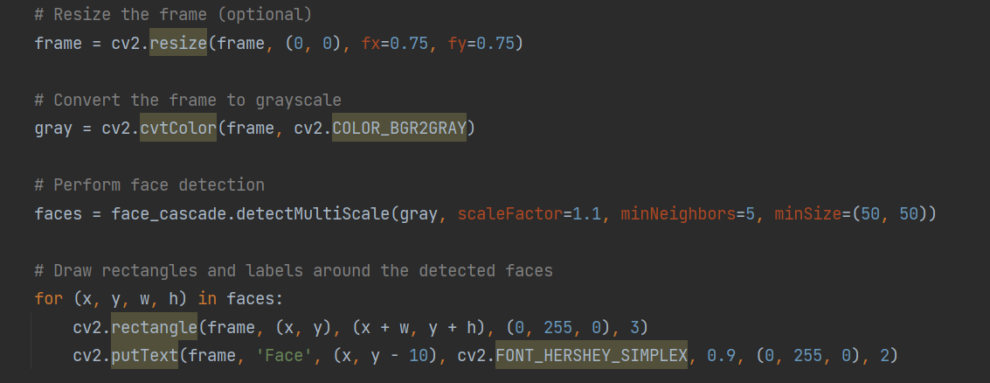

The lines above are said to resize each frame to 75 percent of the original size, then convert to grayscale, then use the detectMultiScale method to perform face detection, then draw the rectangle with the label “face” above it. This is all inside the while loop because we need to be performed on every frame in the video.

The next part is a little different from the image detector.

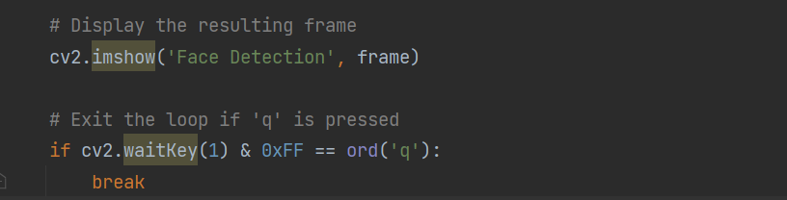

These lines need to be put in the while loop because the imshow function shows the frame in a window named “Face Detection” for every frame read. The while loop iterates through all of the frames, and when we put them all together, we get a coherent video. The line of code if cv2.waitKey(1) & 0xFF == ord('q'): break serves as a condition to check for a specific key press event. It utilizes the cv2.waitKey() function to wait for a key event with a timeout of 1 millisecond. The function returns the key code of the pressed key. The code then performs a bitwise AND operation (&) with 0xFF to extract the last 8 bits of the key code. This extracted value is compared with the ASCII code of the character 'q' using == ord('q'). If the pressed key is 'q', signifying the desire to exit, the condition evaluates to True, and the break statement is executed. This causes the program to break out of the enclosing while loop, allowing the face detection process on the video to stop.

The final lines are used to terminate all of the processes.

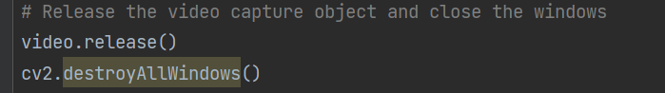

Video.release just stops the video from being read into memory and the destroyAllWindows termites all opencv windows.

**Side Quest**

Before we move on to the next part of the face detection, let’s try this code on a few more videos. But where do we get more videos from? I certainly do not want to get them manually anymore. What if there is an easier way? Well, that is what we are going to be doing now.

**PyTube**

PyTube is a popular Python library used for downloading YouTube videos. It provides a simple and intuitive interface for interacting with YouTube's video streaming and downloading capabilities. PyTube allows you to fetch information about videos, extract metadata, and download videos in various formats and resolutions. Here are some key features and functionalities of PyTube: Video Information Retrieval: PyTube enables you to fetch information about a YouTube video, such as its title, duration, thumbnail URL, and available formats. Video Downloading: The library provides a convenient way to download videos from YouTube. You can specify the desired format and resolution, and PyTube takes care of fetching and saving the video file locally. Audio Extraction: PyTube allows you to extract the audio from a YouTube video and save it as an audio file, such as MP3 or WAV. This feature can be handy if you only want to save the audio content without the video portion. Progressive and Adaptive Streams: YouTube offers videos in multiple formats and resolutions. PyTube supports both progressive and adaptive streams, giving you the flexibility to choose the best option based on your requirements. Callbacks and Event Handling: PyTube provides a way to register callbacks and handle events during the download process. You can track the progress of the download, receive notifications, or perform custom actions at different stages. Caption Extraction: PyTube allows you to extract captions or subtitles associated with a YouTube video. You can retrieve them in various formats, such as SRT (SubRip Text) or VTT (WebVTT). Playlist Support: With PyTube, you can download complete YouTube playlists by providing the URL of the playlist. It automatically fetches all the videos in the playlist and offers the ability to download them sequentially.

To get started with pytube, we first have to learn about something else.

**Introduction to Virtual Environments**

A virtual environment is a powerful tool used in Python development that allows you to create isolated and self-contained environments for your projects. These environments offer a way to separate project-specific libraries, dependencies, and configurations from the global Python installation and other projects. By creating a virtual environment, you can manage and control the exact versions of Python and external packages your project requires, ensuring compatibility and reproducibility. Virtual environments provide a controlled sandbox where you can install, update, and remove packages without affecting other projects or the stability of your system. They are invaluable for managing project dependencies, achieving reproducibility, simplifying deployment, and facilitating testing and development. Whether you're working on a small script or a complex application, virtual environments help maintain a clean and organized development workflow, enabling you to work confidently and efficiently in Python.

We need to create a virtual environment to develop with pytube because otherwise we are going to have some problems and we are going to get frustrated, which we don’t want.

In this example, I will be using VsCode because my PyCharm Environment is very messed up, but feel free to use anything else if you want to. To create a virtual environment in our folder, we have to use this command.



The second venv can be changed to whatever you want because that will be the name of your folder. After you run this you should see a folder in your project folder named what you named your virtual environment. This is not the last step however. We still need to activate the virtual environment. To do this, use the command below.



*Note: This is the command for windows powershell. If you are using a different system or doing this from the command palette, refer to the table below.

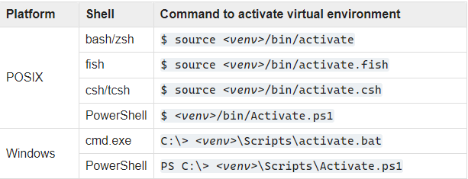

The <venv> is just saying to put your virtual environment name in that spot if you are confused why yours is not working.

When you run this command, you should see something close to this on your terminal.



Now that we are in the virtual environment, we can install the libraries that we want inside. Keep in mind for later that you have to redownload dependencies every time you start a new virtual environment. The only dependency we need in this virtual environment is pytube, so let’s do that using pip install



I already downloaded before writing this so I get the Requirement already satisfied, but you should get an install bar on your screen.

Now we can start developing with Pytube, let’s have some fun!

We can start by creating a new file and importing the libraries we need for this project

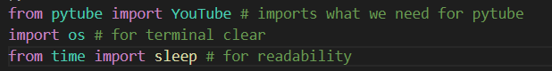

How I want this program to turn out at the end is for the user (right now that’s you) to be able to enter in a youtube video url and that downloads to a folder of the user’s choice. But first, let’s layout the basic structure for the program.

First we need to take in input from the user to enter in the video link.

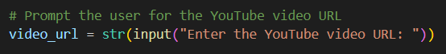

We need to type cast this input to a string because this will ensure there will be no problems with the program later.

Next, we can use pytube’s built-in YouTube() to convert the url to a youtube object.

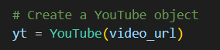

The YouTube object in the PyTube library represents a YouTube video and provides a convenient interface to interact with various properties and functionalities of the video. With a YouTube object, you can retrieve important information about the video, such as its title, length, rating, views, description, author, and more. This allows you to display or process the video's details as needed. Additionally, the YouTube object gives you access to the available video streams associated with the video. These streams represent different formats, resolutions, and encodings. By choosing an appropriate stream from the streams property, you can download the video to your local machine. The download() method of a stream object handles the entire download process, including fetching the video data and saving it as a file. Moreover, the YouTube object allows you to work with captions or subtitles associated with the video. The captions property gives you access to available caption tracks and their respective language codes. This feature is particularly useful if you need to extract or manipulate the subtitles programmatically. The YouTube object also provides the URL of the video's thumbnail image through the thumbnail_url property. You can use this URL to display the thumbnail or programmatically retrieve the image if needed. Furthermore, the metadata property of the YouTube object gives you access to various metadata related to the video. This includes information such as the video's ID, upload date, keywords, category, and more. Accessing this metadata allows you to obtain additional details about the video beyond the basic attributes.

Now that we know what the youtube object can do, let’s print some of the video info so the user can check if they are downloading the right video.

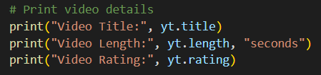

As you can see, this prints out the Title, Length, and Rating of the video we are trying to download. Other information we can get can be found: Title, Length in seconds, Rating, Views, Description, Author. Captions, and the Thumbnail URL: The URL of the video's thumbnail image.

Now that we know how to get info, let’s actually download the video

To download the video at the highest available resolution, we have to write an extra line of code.

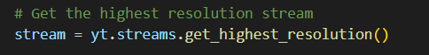

The line stream = yt.streams.get_highest_resolution() retrieves the stream with the highest resolution available for the YouTube video represented by the yt (YouTube) object. When called on the streams property of the YouTube object, the method get_highest_resolution() returns a Stream object. The Stream object represents the video stream that has the best available quality, typically measured in pixels. By using yt.streams.get_highest_resolution(), you ensure that you obtain the Stream object that corresponds to the video stream with the highest resolution. This allows you to perform various operations on this Stream object, such as downloading the video with the best quality using the download() method or accessing other properties and functionalities specific to that stream.

The last step is to download the stream we created. This can be done with a simple line.

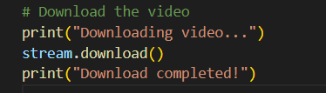

I just added the print statements for extra effect.

Go ahead and test this out on any youtube video. Remember to press the Copy video URL on the video and not the URL bar from the top.

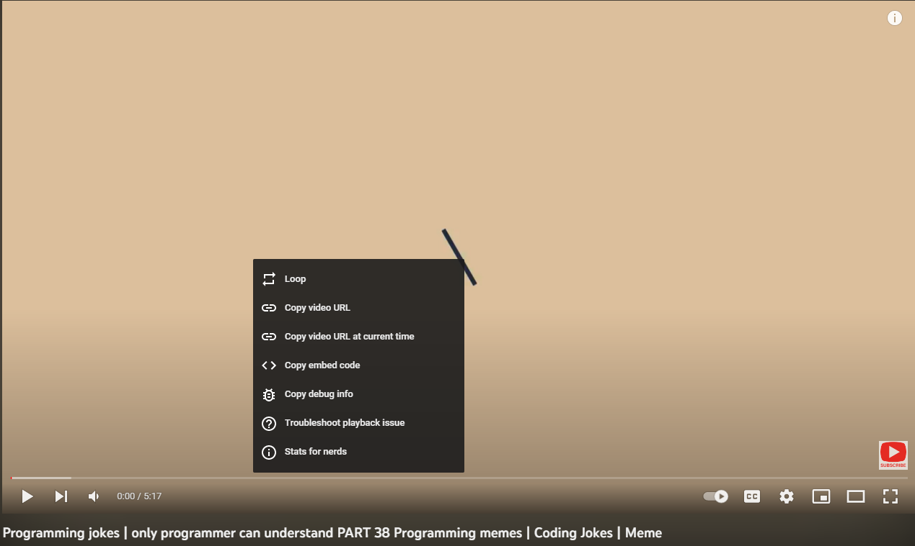

Do it from the actual video itself.

You can run the python file and paste in the url.



Press enter and the video should download to your project folder. Give the download process some time.

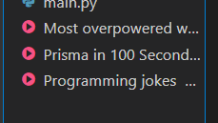

As you can see, the video is in my folder. Don’t mind the other ones, I just did it multiple times.

The code we just created is very simple and easy and it does what we want it to do, but in return, there could be a lot of errors that occur and we do not even get to choose where we download the video to. In this next part, we will improve our code to catch all errors and make it user-friendly.

First let’s lay out all of the features we want to implement. I want to implement error catching to catch if the entered url is wrong or if the user accidentally entered the wrong url. I want the program to restart when this happens. I also want the user to be able to choose the folder destination of the video. Finally, I want the program to catch an error if the download failed for some reason. Let’s start!

The first thing we are going to implement is the loop for if the video the user entered is what they wanted to download. We can do this by implementing a while loop.

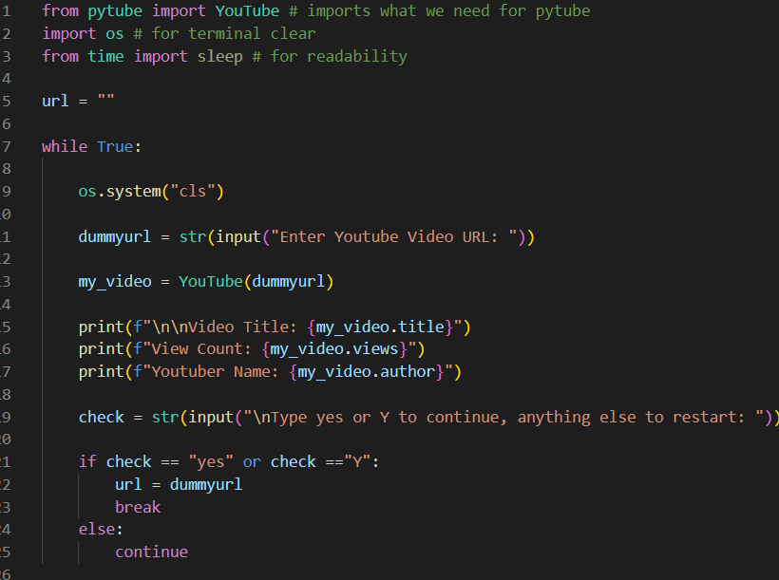

The next page will explain the entire code.

**Code Explanation**

The first line from pytube import YouTube imports the YouTube class from the pytube module. This class allows us to work with YouTube videos, including downloading them.

The second line import os imports the os module, which provides a way to interact with the operating system. In this code, it is used for clearing the terminal screen.

The third line from time import sleep imports the sleep function from the time module. This function is used for introducing delays in the code to improve readability.

The url variable is initialized as an empty string. This variable will be used to store the URL of the YouTube video entered by the user.

The code enters a while loop with the condition True, which means it will keep looping indefinitely until a certain condition is met or a break statement is encountered.

Inside the while loop, the line os.system("cls") is executed to clear the terminal screen. The os.system() function is used to execute a shell command, and in this case, it clears the screen. This step is done to provide a clean interface for the user to input the YouTube video URL.

The line dummyurl = str(input("Enter Youtube Video URL: ")) prompts the user to enter a YouTube video URL and stores it in the dummyurl variable as a string. The input() function is used to take user input from the terminal.

The next line my_video = YouTube(dummyurl) creates an instance of the YouTube class from the pytube library using the dummyurl as the video URL. This allows us to work with the YouTube video specified by the user.

The code then prints information about the video using the print() function. It displays the video title, view count, and the name of the YouTuber who uploaded the video. This information is obtained using properties and methods provided by the YouTube class.

The line check = str(input("\nType yes or Y to continue, anything else to restart: ")) prompts the user to enter "yes" or "Y" to continue with the current video URL, or any other input to restart the process. The user's input is stored in the check variable as a string.

The code then checks the value of check using an if statement. If the value is equal to "yes" or "Y", the url variable is assigned the value of dummyurl (the current video URL) and the while loop is exited with the break statement.

If the user enters anything other than "yes" or "Y", the code continues to the next iteration of the while loop using the continue statement. This restarts the process, prompting the user to enter a new video URL.

The next feature we want to add is the error check for if the url entered is incorrect. We can do this using the python try except method

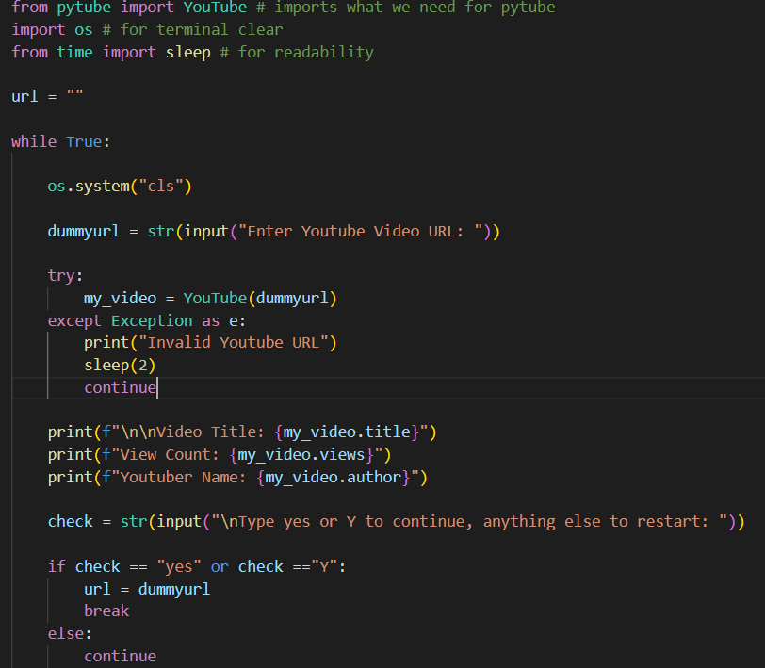

The code tries to execute the following line: my_video = YouTube(dummyurl). It attempts to create an instance of the YouTube class with the dummyurl as the video URL.

If no exceptions occur during the execution of the try block, the code continues with the subsequent lines after the except block.

If an exception occurs during the execution of the try block, the code jumps to the except block.

In the except block, the exception is caught and assigned to the variable e. The Exception class is a base class for all exceptions, so it can catch any type of exception.

The code then prints the message "Invalid Youtube URL" using the print() function. This message indicates that the provided YouTube URL is not valid.

The sleep(2) function is called to introduce a 2-second delay in the execution of the code. This delay improves readability and provides a short pause before the loop continues.

The continue statement is executed, which causes the code to skip the remaining lines in the except block and jump back to the beginning of the while loop. This allows the user to enter a new YouTube URL

The next feature that we want to add is the ability to download the video to a folder of the user’s choice. This one seems simple but actually requires some more steps.

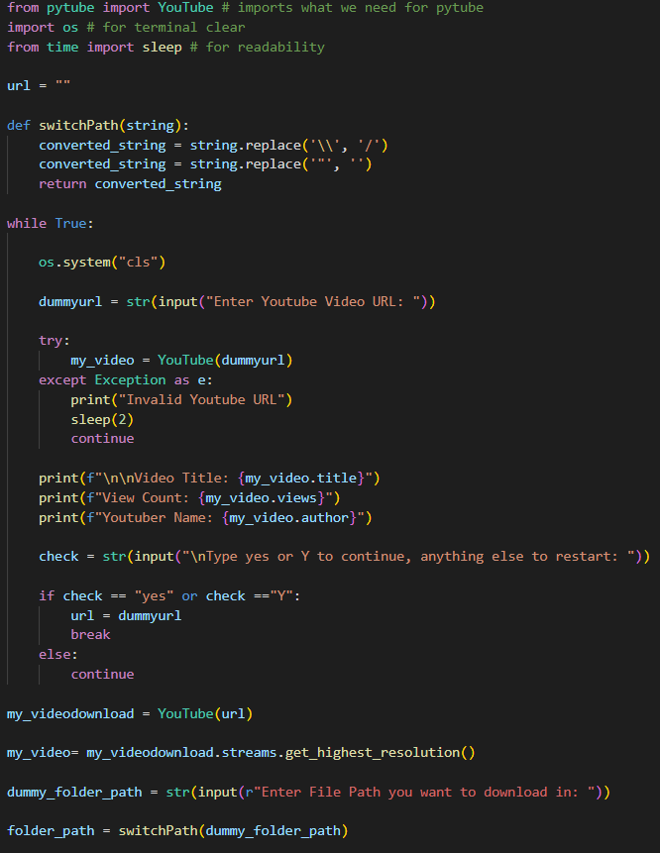

The code added code will be explained on the next page.

1. The code that we added are these parts.

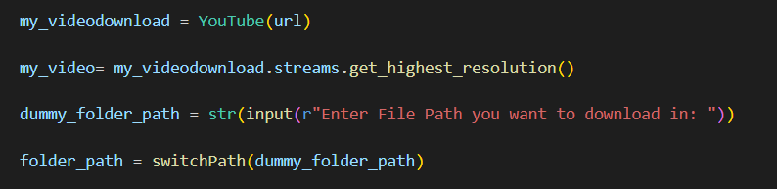

The first line creates a youtube object using the url provided by the user and after the user confirms it. The second line creates a stream that is in the highest possible resolution.

The last two lines are how the user enters the folder for the video to be located in, and it is a little tricky, so I will explain it fully.



We first create a dummy variable that takes in the user input as a string. The r prefix before the input says to take the raw input.

**Mini Lesson: File Paths and Escape Sequences**

The reason we need to take raw user input is because of a little thing called escape sequences. Escape sequences in Python are special character combinations that are used to represent certain characters that are difficult or impossible to type directly into a string. These escape sequences start with a backslash \ followed by one or more characters. Here are some commonly used escape sequences.

\n: Newline

It represents a newline character, which moves the cursor to the beginning of the next line. If you noticed, I actually used this to format the video information

\t: Tab

It represents a horizontal tab character, which adds horizontal spacing.

\b: Backspace

It represents a backspace character, which moves the cursor back one space.

\v: Vertical Tab

It represents a vertical tab character, which adds vertical spacing.

The reason why escape sequences are important to know about is because they are very annoying. In our code, we want the user to be able to enter which folder they want to download the video to. They can do this by entering in a file path. The basic structure of a file path looks like this:

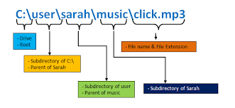

Notice that in the file path, the way that the subdirectories are separated is by using the backslash (\). This makes it very annoying for us. Python thinks this is also annoying which is why file paths in Python have to be written with a / instead of a \.

You can find the file path of the folder you want easily because your computer will automatically do it for you.

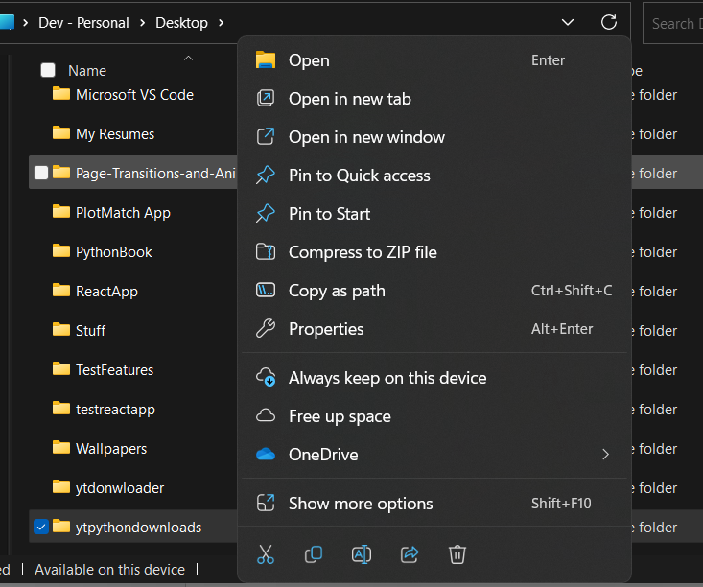

To get to this window, go to the file explorer and find the folder you want to use. Then right click the folder to open up the options menu. Then we can get the path by pressing on this button.



This will give you a file path structured with a \.

My file path looks like this: "C:\Users\bigfi\OneDrive\Desktop\ytdownloads"

This is a problem because python will only accept file paths like this:

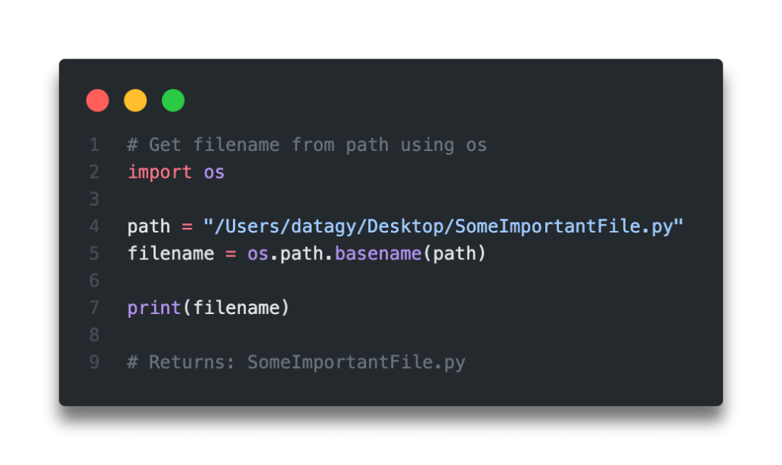

Our goal is for the user to be able to enter the file path with no effort, which means we have to do some more work. For this feature, we have to make the file path entered turn into something like the one above. Let’s get started.



Let’s take a look at this line again. This line enables the user to enter in the file path. We type cast the input as a string for it to be readable by functions easily. We also need to add the prefix r behind the quote to say to take in raw input, which ignores the escape sequences. If you try to do this without the r, it will not work.

Now that we know this we can create code that switches the file path entered to the correctly formatted one.

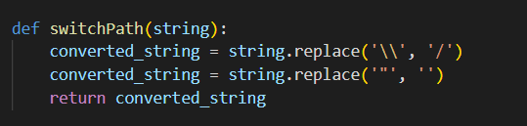

I created a function called switchPath that takes in a variable called string. I then used the built-in python replace functions to replace the backslash with a forward slash. The \\ is an escape sequence that represents the backslash. We then replace the quotes in the path with empty space because otherwise there would be 2 sets of quotes and when you read in the path to a function, it will give us an error.

Recap of what we did so far: we added the loop to allow the user to restart if they did something wrong. We added the error catching for the url, and we added the folder path entering system

So far, our code looks like this:



The final step for this upgraded code is to actually download the video.



When we add this to the end, our code should be working just fine, but let’s just add an error catching system to be safe.

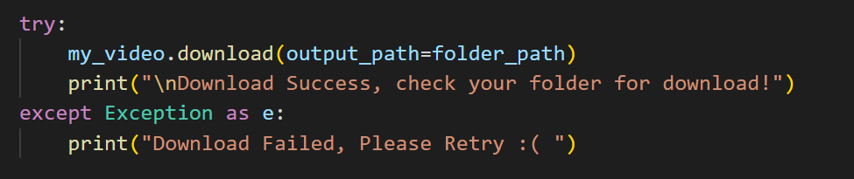

Much better!

The main thing you need to understand about this code is the parameter output_path. Output_path is used to specify the destination of the download, in our case, it is the path that the user entered. The try except is used to catch any error that might occur, whether that be a problem with the file path or the youtube url.

That’s it! We just made our own youtube downloader.

This is the finished code for the program.

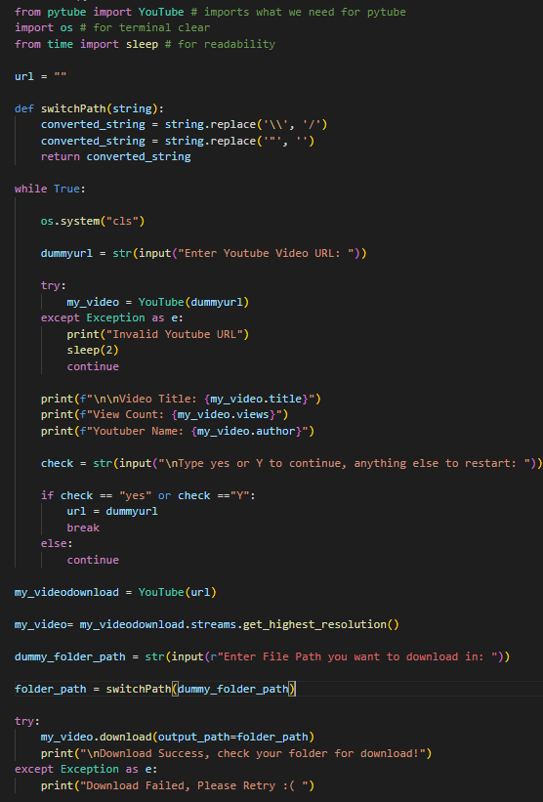

**Youtube downloader recap**

pytube is imported to interact with YouTube videos and perform downloads.

os is imported to clear the terminal screen.

sleep is imported from the time module to introduce delays for better readability.

The script defines a function called switchPath, which converts file paths to a compatible format by replacing backslashes with forward slashes and removing double quotes.

Inside an infinite while loop, the script performs the following steps:

It clears the terminal screen using the os.system("cls") command. This is added at the start to clear if the loop is reset.

The user is prompted to enter a YouTube video URL, which is stored in the dummyurl variable.

An attempt is made to create a YouTube object using the provided URL. If the URL is invalid or an exception occurs, an error message is displayed, and the script waits for 2 seconds before restarting the loop.

Information about the video, such as the title, view count, and author, is printed.

The user is prompted to enter "yes" or "Y" to continue downloading the video or anything else to restart the loop.

If the user's input is "yes" or "Y", the dummyurl is assigned to the url variable, and the loop is exited. Otherwise, the loop continues to the next iteration.

After breaking out of the loop, a YouTube object is created using the chosen URL stored in the url variable.

The script retrieves the video with the highest resolution available using my_videodownload.streams.get_highest_resolution().

The user is prompted to enter the file path where they want to download the video. The switchPath function is used to convert the file path to a compatible format.

The script attempts to download the video to the specified folder path using the my_video.download() method. If successful, a success message is displayed. Otherwise, an error message is printed.

**Back to what we were doing**

I know that was a very long lesson, but remember that it was a side quest. Remember, we were working on a face detection program using opencv. Here is the code we left on and a quick recap of what the code is doing.

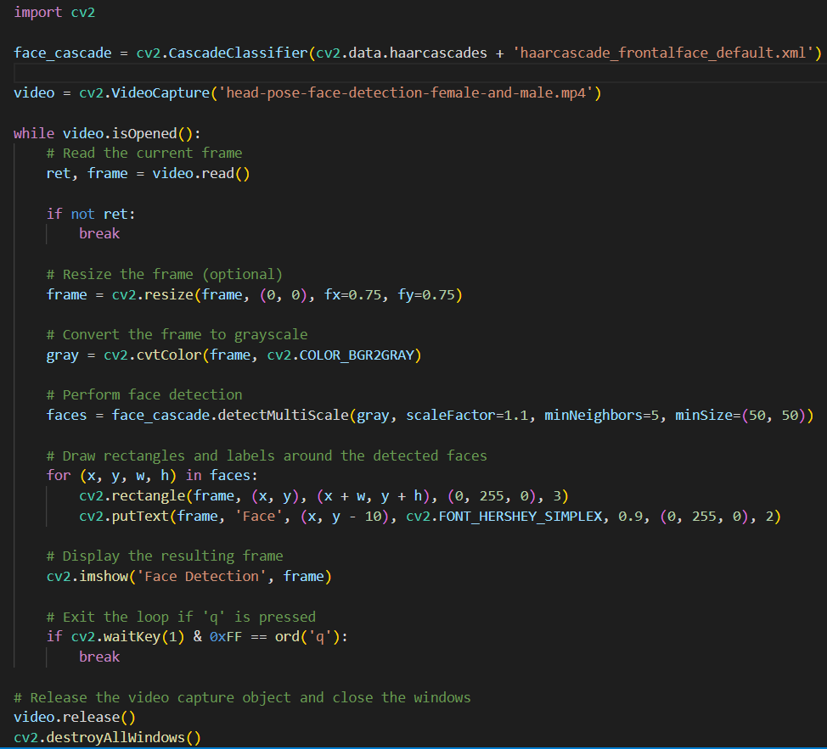

Here's a quick recap of the code:

Importing the required module:

cv2 is imported from the OpenCV library, which is used for computer vision tasks.

The cv2.CascadeClassifier class is used to create an instance of the face cascade classifier.

The XML file for the face cascade classifier is loaded using cv2.data.haarcascades + 'haarcascade_frontalface_default.xml'.

Opening a video file for processing:

The cv2.VideoCapture function is used to open a video file for reading.

The name of the video file ('head-pose-face-detection-female-and-male.mp4') is passed as an argument.

The loop continues as long as the video is opened and readable.

The video.read() function is used to read the current frame from the video.

If ret (a boolean indicating whether the frame was read successfully) is False, the loop breaks.

Preprocessing the frame:

The frame is optionally resized using cv2.resize to make it smaller.

The frame is converted to grayscale using cv2.cvtColor and the cv2.COLOR_BGR2GRAY conversion flag.

Performing face detection:

The face cascade classifier (face_cascade) is used to detect faces in the grayscale frame.

The cv2.CascadeClassifier.detectMultiScale method is called with the grayscale frame as input.

Parameters such as scaleFactor, minNeighbors, and minSize are set to control the face detection process.

Drawing rectangles and labels around detected faces:

For each face detected, a rectangle is drawn using cv2.rectangle to outline the face region.

The cv2.putText function is used to add the label "Face" above each detected face.

Displaying the frame with face detections:

The resulting frame with face detections is displayed using cv2.imshow.

The window is titled "Face Detection".

Exiting the loop:

The loop can be exited if the 'q' key is pressed.

The condition cv2.waitKey(1) & 0xFF == ord('q') checks if the key pressed is 'q'.

If the condition is satisfied, the loop breaks.

After the loop, the video capture object is released using video.release().

All windows created by OpenCV are closed using cv2.destroyAllWindows().

**Integrating the Face Detection and the YTDownloader**

The reason why I added the side quest for the youtube downloader is that we can easily integrate it with our face detection program. If you noticed, all of the video downloads from the program were downloaded with the mp4 format, which is easily readable to opencv. Instead of downloading the video by running one program and then running another program, what if there was a way to automate it? Well, there is, and we are going to do it.

**Implementing External Files**

Before we can integrate both of the programs together, we have to learn about external files and how to implement them. Python actually makes it very easy to implement. Here is a step by step on how to implement external files and then I will provide some code examples.

Step 1: Create a new Python file or open an existing one where you want to use the code from the external file.

Step 2: Create the external Python file with the code you want to import. Save it with a .py extension.

Step 3: In your main Python file, import the functions or variables you want to use from the external file using the import statement.

Step 4: Use the imported functions or variables from the external file in your main Python program.

Step 5: Run your main Python file to execute the code from the external file and produce the desired output.

Let’s go through a basic example using these steps.

I am going to be using vscode for this example, but feel free to use any other IDE or text editor, they will all work the same way. First, we will create a folder to store our files in. Next, we have to create 2 python files in our folder.

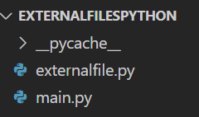

I named my files main and externalfile to easily read between them, but you can give them whatever names you want, just remember to use the right names later on.

To implement an external file, we first have to have some code in our files. Here is some basic code to help us.

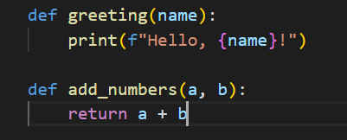

Here we added 2 functions to our external python file. The first function takes in a parameter and concatenates it with Hello to create a simple greeting with a name. The second function takes 2 integers and adds them together. The names for these functions are greeting and add_numbers, which makes it very easy to remember when to use them. Now it is time to implement these in the main file.

To do this we need to use this line.



Notice how this looks similar to when we import libraries. This is because libraries are just external files, but now we created our own external file, so we can import that. This line just says to import all functions in the external files to our main file. Now we can use the functions that are in the other file in our main file.

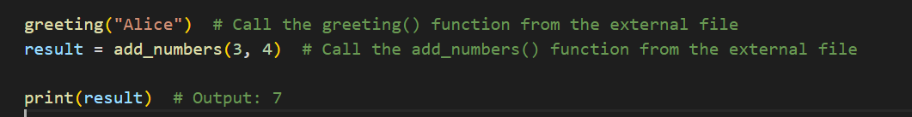

The output for this code should be Hello, Alice and 7. Now that we know how to implement files, we can use this to integrate the face detector and the youtube downloader. The way I want to approach this is to implement the youtube file into the face detector file. This means we have to make the youtube download program into functions.

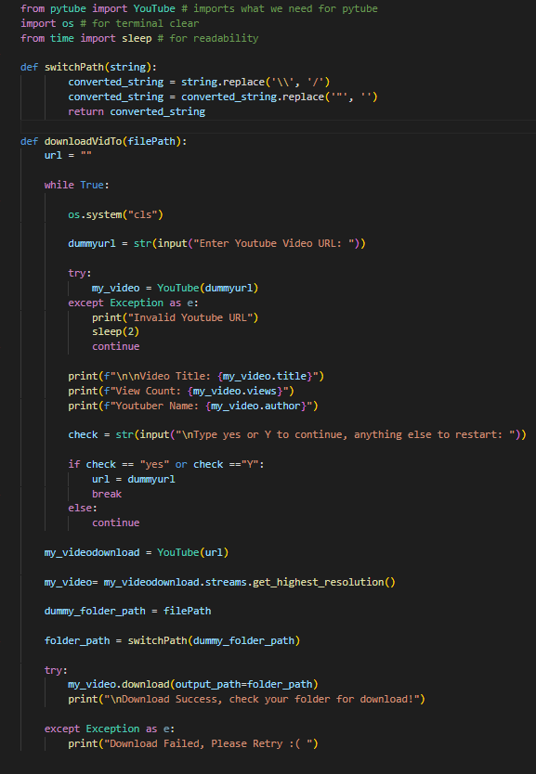

This code is very similar to the finished downloader we had before, but there are some changes I made. The first thing I did was wrap the main logic code into a function called downloadVidTo. This function takes a parameter that we call filepath. I thought that this would be a more efficient way we can write this because we do not have to enter in a file path every time we want to download a video. The switchPath function is separate because it is easier to use as you will see now.

The next thing we need to do is actually implement this code to the main file.

Before I show you the code, let’s try to think how we would do this.

First, we have to import the external files, which allows us to use the functions we created in the main file.

Next, we have to use the functions that we wrote, but we have to decide how to do this. There are multiple ways that we can do this, but the way that I did it was to set a variable called vidPath that stored the path by using the switchPath function from the other file.

Then, we can call our main function by passing the vidPath variable as a parameter.

This is what the finished code looks like.

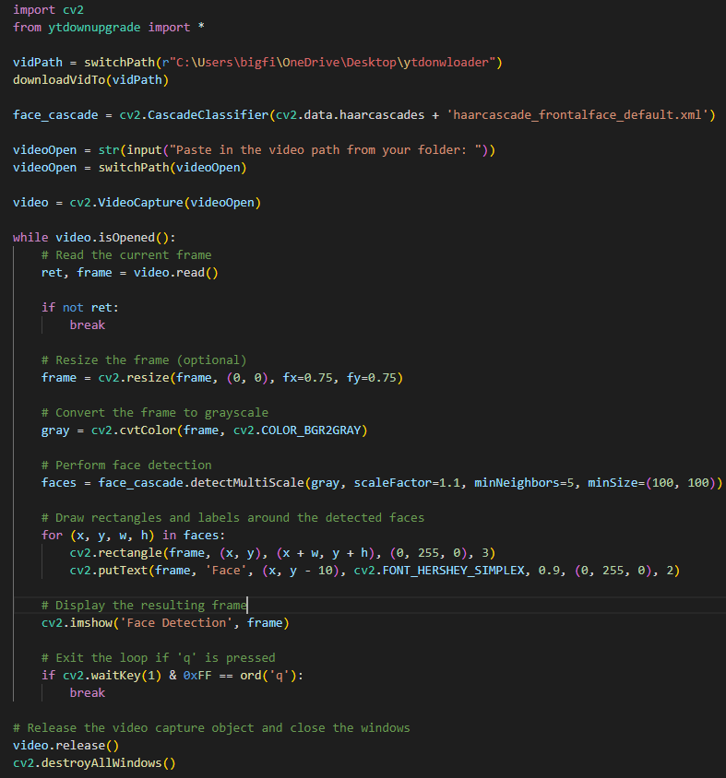

As you can see at the start, we have called the 2 functions from the youtubedownupgrade file.

After the video is downloaded to the folder of the user’s choice, we then prompt the user to enter the file path for the video, which is then converted using the same switchPath function, which is then used by our face detector to perform the detection on the video.

Here is a quick summary of both of the files and what they do.

The youtubedownloader file:

The script prompts the user to enter a YouTube video URL and validates it. If the URL is invalid, an error message is displayed, and the user is prompted again. Once a valid URL is provided, the script displays information about the video, such as the title, view count, and the name of the YouTuber.

The user is then asked to confirm whether they want to proceed with the download. If the user responds with "yes" or "Y," the video is downloaded in the highest available resolution. The script uses the os module to clear the terminal screen for better readability during the process.

The downloaded video is saved to the specified file path, which is provided as an argument to the downloadVidTo function. The switchPath function is used to convert the file path to a valid format by replacing backslashes with forward slashes and removing double quotes.

If the download is successful, a success message is displayed, and the user is informed to check their specified folder for the downloaded video. Otherwise, if an error occurs during the download, a failure message is displayed, and the user is encouraged to retry.

The face detection file:

The provided Python script uses OpenCV (cv2) to detect faces in a video. It imports necessary modules and potentially a custom module called ytdownupgrade.

The script sets up the video file path and downloads the video using the switchPath and downloadVidTo functions respectively.

A Haar cascade classifier is created to detect faces based on the pre-trained XML file haarcascade_frontalface_default.xml.

The user is prompted to enter the video path, which is then converted to a valid format using switchPath.

The script reads frames from the video, optionally resizes them, converts to grayscale, and performs face detection using the cascade classifier.

Detected faces are annotated on the original color frame and displayed in a window titled "Face Detection". The program exits when the 'q' key is pressed.

Finally, the script releases the video capture object and closes all windows.

**Face Detection with Camera**

Now that we learned about face detection with images and videos, let’s move on to face detection with your camera to detect your face as well as your eyes. By the end of this chapter, we are going to be able to detect our face and eyes through our camera and we will do our final coding problem where we calculate the length of facial features.

The basic code is almost identical to our code from the one that we used to detect faces in a video, but there are a few key differences we have to create. The first being how to access the camera from our code and the second being how to detect the eyes.

Let’s start!

First we need to import the packages that we need.



Since we want to do eye detection also, we need to read in another haar feature file that is also provided by opencv.



Now that we have the haar feature files, we need to access the camera to use. Opencv makes it very easy to do this as there is a built-in function.

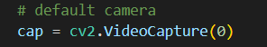

Here, we stored our camera in a variable named cap so we can use it later. The 0 in the VideoCapture function specifies to use the computer’s default camera. Now that we have this we can write our program’s main logic. First we can take our same code for the video with the while loop to read in all of the frames.

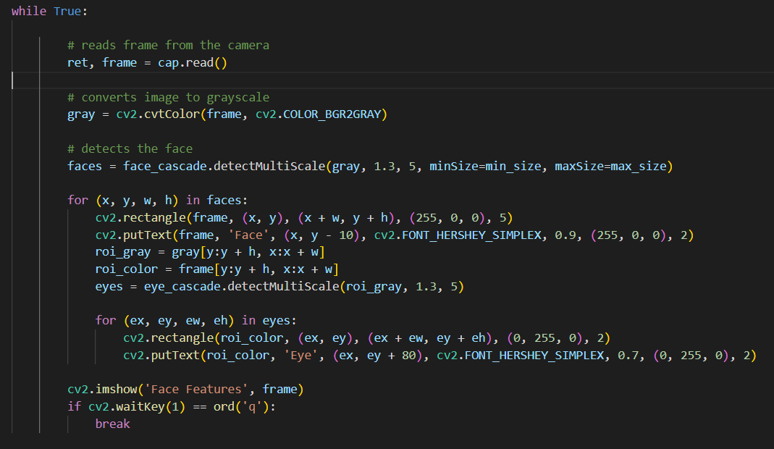

Here is the full explanation for this code:

ret, frame = cap.read(): This line reads a frame from the camera using the cap object, which represents the video capture device. The return value ret indicates whether the frame was successfully read, and the captured frame is stored in the frame variable.

gray = cv2.cvtColor(frame, cv2.COLOR_BGR2GRAY): This line converts the captured frame from color (BGR) to grayscale. Grayscale images only have intensity values (shades of gray) but no color information.

faces = face_cascade.detectMultiScale(gray, 1.3, 5, minSize=min_size, maxSize=max_size): This line uses the face_cascade object (which is a pre-trained Haar cascade classifier) to detect faces in the grayscale image. The detectMultiScale function performs the face detection using the Haar cascades. It returns a list of rectangles representing the detected faces. The parameters 1.3 and 5 control the scaling factor and minimum number of neighbors, respectively, for the detected faces. minSize and maxSize are the minimum and maximum size limits for the detected faces.

The loop for (x, y, w, h) in faces: iterates over each detected face, represented by the (x, y, w, h) tuple. These values represent the coordinates of the top-left corner (x, y) and the width and height (w, h) of the rectangle bounding the face.

cv2.rectangle(frame, (x, y), (x + w, y + h), (255, 0, 0), 5): This line draws a rectangle around the detected face on the frame image using the cv2.rectangle function. The rectangle's coordinates are determined by (x, y) (top-left corner) and (x + w, y + h) (bottom-right corner). The (255, 0, 0) argument specifies the color of the rectangle in BGR format (blue in this case), and 5 is the thickness of the rectangle's border.

cv2.putText(frame, 'Face', (x, y - 10), cv2.FONT_HERSHEY_SIMPLEX, 0.9, (255, 0, 0), 2): This line adds a text label ("Face") above the rectangle using the cv2.putText function. The text is positioned at (x, y - 10), and cv2.FONT_HERSHEY_SIMPLEX specifies the font type. The parameters 0.9, (255, 0, 0), and 2 control the font scale, color, and thickness of the text, respectively.

roi_gray = gray[y:y + h, x:x + w] and roi_color = frame[y:y + h, x:x + w]: These lines extract the regions of interest (ROI) from the grayscale image (roi_gray) and the original frame (roi_color). The ROI represents the detected face region within the respective images.

eyes = eye_cascade.detectMultiScale(roi_gray, 1.3, 5): This line applies the eye cascade classifier (eye_cascade) to detect eyes within the region of interest (roi_gray). It returns a list of rectangles representing the detected eyes.

The inner loop for (ex, ey, ew, eh) in eyes: iterates over each detected eye within the ROI. Similar to the face detection, the `(ex, ey), (ex + ew, ey + eh), (0, 255, 0), 2): This line draws a rectangle around the detected eye on the roi_color image, which represents the region of interest containing the face. The rectangle's coordinates are determined by (ex, ey) (top-left corner) and (ex + ew, ey + eh) (bottom-right corner). The (0, 255, 0) argument specifies the color of the rectangle in BGR format (green in this case), and 2 is the thickness of the rectangle's border.

cv2.putText(roi_color, 'Eye', (ex, ey + 80), cv2.FONT_HERSHEY_SIMPLEX, 0.7, (0, 255, 0), 2): This line adds a text label ("Eye") below the rectangle representing the detected eye. The text is positioned at (ex, ey + 80), and cv2.FONT_HERSHEY_SIMPLEX specifies the font type. The parameters 0.7, (0, 255, 0), and 2 control the font scale, color, and thickness of the text, respectively.

cv2.imshow('Face Features', frame): This line displays the modified frame image, which includes the detected faces and eyes, in a window with the title "Face Features" using the cv2.imshow function.

if cv2.waitKey(1) == ord('q'):: This line waits for a key press for 1 millisecond. If the pressed key is 'q' (as indicated by ord('q')), the loop is terminated using break, and the program moves to the finally block.

After we press the q key, we break out of the loop, which should close all of the windows that we created, so let’s do that.

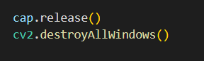

That’s it, we just created our face detector that also detects eyes through our camera.

Let’s see what it should look like.

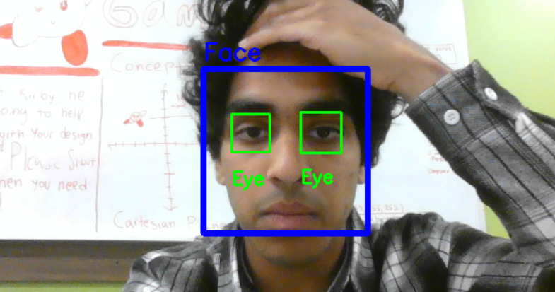

My hair was getting in the way, so just keep that in mind if yours is not working. Also it will not work if you move your head to the side because remember we are using the frontal haar features only.

**Coding Problem #2**

It’s time for our second and final coding problem!

Description:

You are tasked with developing a program that utilizes computer vision techniques to calculate various facial features in real-time from a webcam feed. The program will employ Haar cascades for face and eye detection, allowing for accurate identification and measurement of these features.

The program begins by accessing the webcam and reading frames sequentially. Each frame is then converted to grayscale for efficient feature detection. Using a pre-trained Haar cascade classifier specifically designed for face detection, the program identifies and localizes faces within the frame.

For each detected face, the program draws a bounding rectangle around it and labels it as "Face." Additionally, the region of interest (ROI) corresponding to the face is extracted from both the grayscale and color frames.

Within the ROI, the program applies another Haar cascade classifier, specifically designed for eye detection, to identify and localize the eyes. Similar to face detection, the program draws bounding rectangles around each detected eye and labels them accordingly.

As the program analyzes subsequent frames, the detected faces and eyes are continually updated, providing real-time tracking and measurement of facial features. The program displays the modified frames, including the annotated face and eye detections, in a separate window.

To calculate the approximate width and height of the face, the program uses the detected face's width and height values in pixels. By converting these values to inches, taking into account the screen's DPI and a scale multiplier, it provides an estimation of the face's physical dimensions.

Finally, the program prints the calculated facial features, including the approximate width and height of the face, as well as the approximate width and height of the eyes, to a text file. It also releases the webcam feed, closes all windows, and exits gracefully when the user presses the 'q' key.

This coding problem challenges you to understand and modify the given code to accurately detect and calculate facial features in real-time. You will need to leverage the concepts of Haar cascades, image manipulation, ROI extraction, and coordinate calculations to implement the required feature measurements.

**Boilerplate Code**

Here is the code to get the dpi of the screen.

First we need to import the ctypes and the tkinter libraries.

ctypes is a Python library that provides a way to call functions in dynamic link libraries/shared libraries and to manipulate C-compatible data types in Python. It allows Python programs to interact with code and libraries written in other programming languages, such as C or C++. With ctypes, you can load and use functions and variables from these external libraries directly in your Python code. This enables seamless integration between Python and lower-level languages, giving you access to additional functionality and resources.

tkinter is the standard Python interface to the Tk GUI toolkit. It provides a set of modules that allow you to create and interact with graphical user interfaces (GUIs) in a cross-platform manner. Tkinter provides a wide range of widgets, such as buttons, labels, text boxes, and canvas, which you can use to build interactive and visually appealing applications. It also provides mechanisms for handling user events, like mouse clicks and keyboard inputs, and for organizing and arranging the widgets within windows and frames. Tkinter is easy to use and widely adopted, making it a popular choice for developing desktop applications with Python.

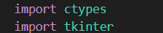

Next, we can use this code to get the dpi of the screen.

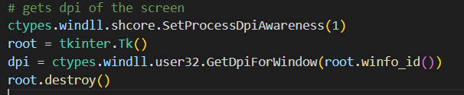

ctypes.windll.shcore.SetProcessDpiAwareness(1): This line sets the DPI awareness level of the current process to 1. DPI awareness is a feature that allows applications to scale their graphical user interfaces appropriately based on the DPI settings of the screen. By setting it to 1, the process becomes DPI aware, enabling it to retrieve accurate DPI information.

root = tkinter.Tk(): This line creates a new instance of the Tk class from the tkinter library, which represents the main window of a Tkinter application. The Tk class is responsible for managing the application's event loop and creating the GUI elements. Creating this instance initializes the underlying Tkinter framework.

dpi = ctypes.windll.user32.GetDpiForWindow(root.winfo_id()): This line retrieves the DPI value for the root window using the GetDpiForWindow function from the user32 library in ctypes.windll. The root.winfo_id() method returns the window identifier of the root window, which is required as an argument for the GetDpiForWindow function.

root.destroy(): This line destroys the root window, releasing any resources associated with it. This step is important to clean up after retrieving the DPI value and before exiting the program.

I also want to print the output on a different file. We can do this easily using the built in sys library and redirecting our print statements to a text file.

First we need to import the sys library. Our libraries imported so far are this:

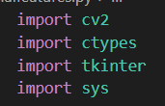

Redirecting the output is very simple, all we need are these lines.

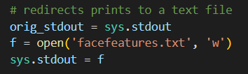

orig_stdout = sys.stdout: This line saves the original standard output stream (stdout) in a variable named orig_stdout. The stdout stream is responsible for displaying the output of print statements in the console.

f = open('facefeatures.txt', 'w'): This line opens a file named "facefeatures.txt" in write mode ('w') and assigns the file object to the variable f. The 'w' mode indicates that if the file already exists, its contents will be overwritten; otherwise, a new file will be created.

sys.stdout = f: This line redirects the stdout stream to the file object f. Now, any subsequent print statements will write their output directly to the "facefeatures.txt" file instead of appearing in the console.

To switch back the redirect you have to put this at the end of the file.

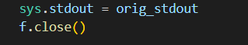

These lines just switch the outputs back to normal and close the text file.

Ok, now it’s time for you to calculate the height and width of the face and eyes. I want this done in inches. Try to do this problem without looking at the solution first. The solution and explanation will be provided on the next page. Good luck!

**Coding Problem #1 Solution Part 1**

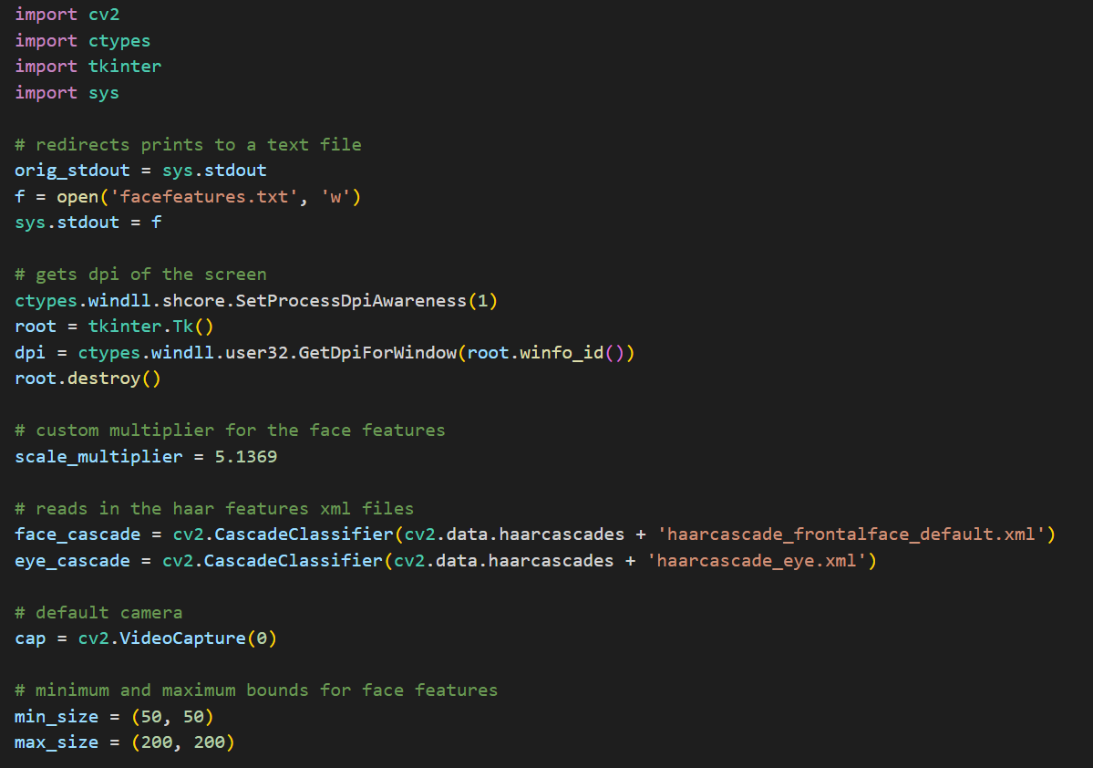

**Coding Problem #1 Solution Part 2**

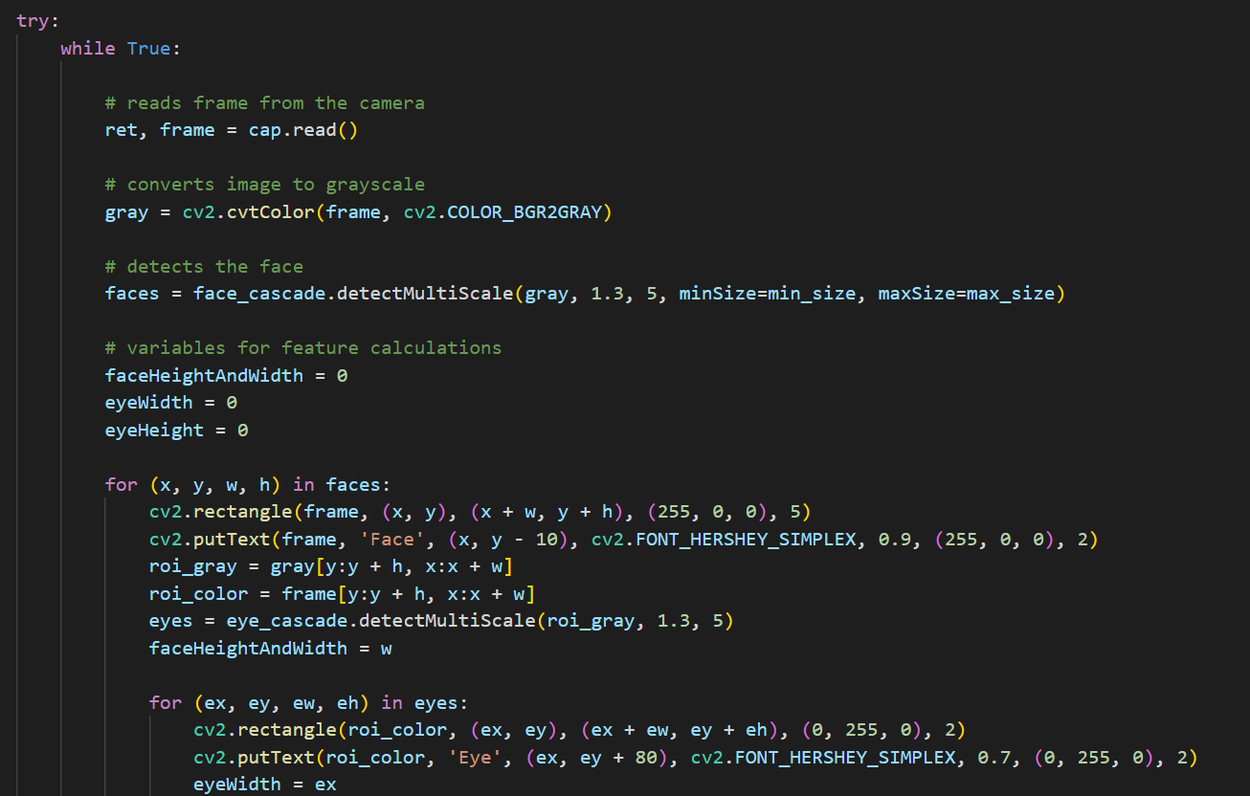

**Coding Problem #1 Solution Part 3**

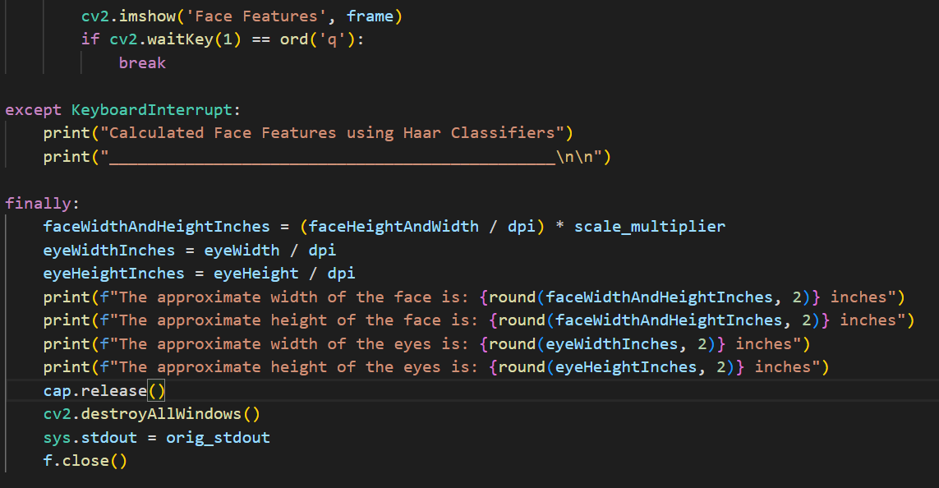

**Coding Problem #1 Solution Explanation**

The code imports the necessary libraries: cv2 for computer vision operations, ctypes for interacting with external libraries, tkinter for creating GUI applications, and sys for system-specific parameters and functions.

It redirects the print statements to a text file named "facefeatures.txt" for capturing program output. The original stdout stream is saved in the variable orig_stdout, and the sys.stdout is redirected to the file using the open() function.

It sets the DPI awareness level of the current process to 1 using ctypes.windll.shcore.SetProcessDpiAwareness(1). This allows the program to be aware of the DPI settings of the screen and perform DPI-dependent operations.

It creates a Tk instance from tkinter to retrieve the DPI value of the screen. The GetDpiForWindow function from ctypes.windll.user32 is used to obtain the DPI value, which is then assigned to the variable dpi. The root.destroy() statement destroys the Tk instance.

It loads the Haar cascade XML files for face and eye detection using cv2.CascadeClassifier. The XML files contain trained models for detecting faces and eyes.

It initializes the default camera using cv2.VideoCapture(0).

The minimum and maximum bounds for face features are defined as min_size and max_size, respectively.

Inside the try block, the code enters a loop that continuously reads frames from the camera, converts them to grayscale, and detects faces using the face_cascade.detectMultiScale function. For each detected face, it draws a rectangle and adds a label on the frame. It then extracts the region of interest (ROI) for eyes within the face region and detects eyes using the eye_cascade.detectMultiScale function. The dimensions of the detected face and eyes are stored in variables for further calculations.

The frames with drawn face and eye rectangles are displayed using cv2.imshow. If the user presses 'q', the loop is exited.

If a keyboard interrupt (Ctrl+C) occurs, the code prints a message indicating the calculated face features using Haar classifiers.

In the finally block, the code performs calculations to convert the face and eye dimensions from pixels to inches using the DPI value. The approximate widths and heights of the face and eyes are printed.

The camera is released, the OpenCV windows are closed, and the stdout is restored to its original state. The file is closed, completing the redirection of print statements to the text file.

I want to talk a little about the custom multiplier that I included on top. Basically, I was seeing that I was not getting the right length for the face so I actually took a tape measure and measured my face and divided that length by the length I was getting from the program. This ensured I was getting a good approximate of the length of the face.

**Math Behind Coding Problem #2**

Let’s go over how we did the calculations for the facial features. If you remember, the detectMultiScale function returned 4 numbers, 2 representing the starting points, and 2 that are the widths. The way that we calculate the lengths is by taking the widths that are returned in pixels and converting them to the same lengths in inches. Here is a step by step.

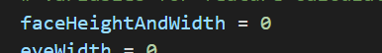

We declare this variable outside of the for loop so that we can use it to store the width returned.

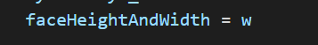

Inside the for loop, we set the variable equal to the width returned.



We then calculated it into inches by dividing the length of pixels by the screen’s dpi or PPI.

We have to do this because of how screens work.

To calculate inches from pixels, you need to know the pixel density or pixels per inch (PPI) of the device or display you're working with. The formula to convert pixels to inches is as follows:

Inches = Pixels / PPI

Here's a step-by-step guide on how to calculate inches from pixels:

Determine the pixel density or PPI of the device or display. You can usually find this information in the specifications or settings of the device, or you can search for it online. For example, a common pixel density for computer monitors is 96 PPI. We found the PPI of the screen using the ctypes and tkinter library to do this for us automatically

Identify the number of pixels you want to convert to inches. Let's say you have 800 pixels.

Plug the values into the formula:

Inches = 800 pixels / 96 PPI

Perform the calculation:

Inches = 8.33 inches

So, 800 pixels would be approximately equal to 8.33 inches on a device with a pixel density of 96 PPI.

Remember that the calculated inches value is an approximation, as pixel density can vary between devices. Additionally, keep in mind that this calculation is primarily useful for on-screen measurements and may not accurately translate to physical printouts or other non-screen applications.

If you are confused why dividing pixels by PPI works, we can prove this by some dimensional analysis.

Dimensional analysis is a mathematical technique used to convert between different units of measurement by considering the dimensions or units of the quantities involved. Let's use dimensional analysis to understand how dividing pixels by PPI gives us inches.

In dimensional analysis, we assign dimensions or units to the quantities involved in a calculation. Here, we'll assign the following dimensions:

Pixels: [P]

PPI: [PPI]

Inches: [L]

Now, let's analyze the equation:

Inches = Pixels / PPI

Breaking down the dimensions:

[L] = [P] / [PPI]

In this case, the dimensions on the right side of the equation cancel each other out, leaving us with the dimension of inches on the left side.

Now, let's focus on the numerical values:

Suppose we have a certain number of pixels, represented by 'P,' and a certain number of pixels per inch, represented by 'PPI.' Dividing 'P' by 'PPI' gives us a ratio of pixels to PPI, which can be interpreted as the number of pixels per inch. This ratio essentially tells us how many pixels are packed into one inch of the display.

By dividing the number of pixels by the pixels per inch, we essentially remove the pixel dimension and are left with the dimension of inches. This calculation allows us to convert the pixel measurement to an inch measurement based on the density of pixels on the display (PPI).

We repeated the same steps for the eye widths and lengths and rounded the numbers calculated to 2 decimal places so it is easier to read as seen here.

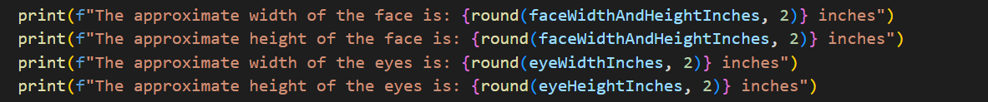

**Conclusion: Python: Not for Dummies**

As we conclude this captivating journey through the pages of Python: Not for Dummies, we hope you've realized the vast potential and endless possibilities that lie within the realm of this powerful programming language. From its intuitive syntax to its versatility, Python has proven time and again to be the go-to language for developers and enthusiasts alike.

Throughout this book, we have delved into the depths of various Python libraries, unraveling their secrets and showcasing their remarkable capabilities. From the immersive worlds of Pygame to the visual wonders of Matplotlib, from the magic of Pytube to the image processing marvels of OpenCV, and from the elegant user interfaces of Tkinter to the mathematical applications in computer science, you have witnessed a fraction of Python's immense ecosystem.

But let us make one thing clear: our exploration has merely scratched the surface of what Python has to offer. Countless libraries, frameworks, and applications await your discovery. From data science and machine learning to web development and automation, Python continues to evolve and push boundaries.

As you close this book, we invite you to take a moment to reflect on the incredible power you now hold within your hands. Armed with the knowledge of Python's libraries and their potential, you possess the tools to create interactive games, craft stunning visualizations, manipulate digital media, build user-friendly interfaces, and unlock the secrets of mathematics within computer science.

Yet, this is just the beginning of your journey. Python, a language that never ceases to amaze, has so much more to offer. Embrace the curiosity that brought you here and venture further. Dive into the uncharted realms of natural language processing, delve into the intricate world of deep learning, explore the wonders of web scraping, or embark on the path of data analysis and visualization.

Remember, Python is not just a language for dummies; it is a gateway to a world of innovation and creativity. So, take that next step, continue your pursuit of knowledge, and uncover the extraordinary possibilities that await. The world of Python beckons, and it is yours to conquer.

May your journey be filled with endless discoveries, triumphant moments, and the joy of mastering this versatile language. Python awaits your command, ready to turn your imagination into reality.

**Code Reviews**

This section is just a recap of all the projects we made in this book.

**Coding Problem #1 Solution**

**import pygame**

**pygame.init()**

**# Set up the display**

**screen_width = 800**

**screen_height = 600**

**screen = pygame.display.set_mode((screen_width, screen_height))**

**# Set up the clock**

**clock = pygame.time.Clock()**

**# Define the object's position and velocity vectors**

**pos = pygame.math.Vector2(screen_width/2, screen_height/2) #sets the position of the ball in the middle of the screen**

**vel = pygame.math.Vector2(0, 0)**

**# Define the object's speed and acceleration**

**maxVel = 5**

**acceleration = 0.5**

**# Define a function to update the object's position and velocity**

**def update_position(vel, pos):**

**# Apply acceleration to the velocity vector**

**keys = pygame.key.get_pressed()**

**if keys[pygame.K_UP]:**

**vel += pygame.math.Vector2(0, -acceleration) # you might be confused why this is negative**

**if keys[pygame.K_DOWN]: # since y position is 0 at the top of the screen instead of the bottom, it will be opposite**

**vel += pygame.math.Vector2(0, acceleration) # this is different from what you have learned in math classes so far**

**if keys[pygame.K_LEFT]:**

**vel += pygame.math.Vector2(-acceleration, 0)**

**if keys[pygame.K_RIGHT]:**

**vel += pygame.math.Vector2(acceleration, 0)**

**# Limit the speed of the velocity vector so it doesnt go at infinite speed, this is how it works in a lot of games too**

**if vel.length() > maxVel:**

**vel.scale_to_length(maxVel)**

**# Update the position vector based on the velocity vector**

**pos += vel**

**# Define a function to draw the object on the screen**

**def draw_object():**

**# Draw a circle at the object's position**

**pygame.draw.circle(screen, (255, 255, 255), (int(pos.x), int(pos.y)), 20)**

**# Main game loop**

**while True:**

**# Handle events**

**for event in pygame.event.get():**

**if event.type == pygame.QUIT:**

**pygame.quit()**

**quit()**

**# Clear the screen**

**screen.fill((0, 0, 0))**

**# Update the object's position and velocity**

**update_position(vel, pos)**

**# Draw the object on the screen**

**draw_object()**

**# Update the display**

**pygame.display.update()**

**# Limit the frame rate**

**clock.tick(60)**

**Coding Problem #1 Solution Explanation**

I know some of the code looks confusing even with the comments so I will explain some of the most important pieces in detail.

**# Define the object's position and velocity vectors**

**pos = pygame.math.Vector2(screen_width/2, screen_height/2) #sets the position of the ball in the middle of the screen**

**vel = pygame.math.Vector2(0, 0)**

These 2 lines declare two pygame vector2’s. This looks really fancy but it is basically just a normal vector that integrates well with the pygame library, so it is a more efficient way than normal python lists. If you used regular lists, that is also correct.

**def update_position(vel, pos):**

**# Apply acceleration to the velocity vector**

**keys = pygame.key.get_pressed()**

**if keys[pygame.K_UP]:**

**vel += pygame.math.Vector2(0, -acceleration)**

**if keys[pygame.K_DOWN]:**

**vel += pygame.math.Vector2(0, acceleration)**

**if keys[pygame.K_LEFT]:**

**vel += pygame.math.Vector2(-acceleration, 0)**

**if keys[pygame.K_RIGHT]:**

**vel += pygame.math.Vector2(acceleration, 0)**

This function updates the position and velocity of the circle object based on the player's input. If the player presses the up arrow key, the velocity in the y-direction is decreased (since the y-coordinate is zero at the top of the screen). If the player presses the down arrow key, the velocity in the y-direction is increased. If the player presses the left or right arrow key, the velocity in the x-direction is changed accordingly. The function also limits the speed of the velocity vector to the maximum speed set earlier.

**Coding Problem #1 Solution Explanation**

**if vel.length() > maxVel:**

**vel.scale_to_length(maxVel)**

In this code, .length() is a method that returns the magnitude (also called length or norm) of the vector vel. The if statement checks whether the magnitude of the velocity vector is greater than the maximum velocity variable. If it is, then the scale_to_length() method is called on the vel vector to scale it down to the maximum velocity while maintaining the same direction. The scale_to_length() method is another method provided by the Pygame Vector2 class. It takes a single argument, which is the desired length for the vector, and scales the vector to that length while preserving its direction. In this case, it scales the vel vector down to the maximum speed maxVel. This is a common technique used in game programming to prevent objects from moving faster than they should. By limiting the speed of an object in this way, the game becomes more realistic and controllable.

**while True:**

**for event in pygame.event.get():**

**if event.type == pygame.QUIT:**

**pygame.quit()**

**quit()**

**screen.fill((0, 0, 0))**

**update_position(vel, pos)**

**draw_object()**

This code is our game’s main logic. The for loop runs until the user presses the X button to close the terminal. The first thing that occurs every iteration of the loop is the reset of the screen. Then it calls our function that updates the position vector. The last function call is to draw our circle on the screen at the position given by the other function.



Let’s start by importing the libraries that we need.

import matplotlib.pyplot as plt

For this example we will be using the draw function to move the circle to where we click on the plot and redraw it at the position of the click. Let’s start by declaring the circle’s properties.

x0, y0 = 0.5, 0.5

radius = 0.1

Next, we can create our function to draw the initial circle

def draw_circle():

global circle

circle = plt.Circle((x0, y0), radius, color='blue')

ax.add_artist(circle)

Notice that we need to make the circle a global variable to use for later. Drawing a circle is pretty simple as we can use matplotlib’s built-in **circle class that takes the initial, position, radius, and color to form the circle**. The add_artist() function is a method in Matplotlib that is used to add an artist object to the plot. In Matplotlib, an artist is a basic visual element that can be added to the plot, such as a line, text, image, or patch. When you create an artist object, it is not automatically added to the plot. Instead, you need to call the add_artist() method and pass the artist object as an argument to add it to the plot. Once the artist is added to the plot, you can modify its properties using other Matplotlib methods. The **add_artist() function is often used to add complex shapes or polygons to the plot, such as circles, rectangles, or polygons**, which can be created using the Circle(), Rectangle(), or Polygon() classes in Matplotlib. These shapes are not created using the plot() function, which is used to create simple lines or scatter plots, but rather using the appropriate Matplotlib artist classes and then adding them to the plot using add_artist().

At this point we can plot our initial circle on the graph to test it.

fig, ax = plt.subplots()

draw_circle()

# Set the plot limits and show the plot

ax.set_xlim(0, 10)

ax.set_ylim(0, 10)

plt.show()

The plt.subplots() function is a method in Matplotlib that is used to create a figure and one or more subplots. In Matplotlib, a figure is the overall window or container that contains one or more subplots, while a **subplot is a smaller plot within the larger figure**. The subplots() function is a convenient way to create a figure and one or more subplots in a single line of code. The subplots() function returns two values: **a Figure object and an array of Axes objects (fig and ax)**. The Figure object is the overall container for the plot, while the Axes objects are the individual subplots within the figure. The Axes objects can be used to customize the properties of each subplot, such as setting the x- and y-axis limits, adding titles or labels, etc. The plt.subplots() function is useful because it simplifies the process of creating multiple subplots in a single figure, and ensures that the subplots are properly aligned and spaced. Additionally, it returns the Figure and Axes objects, which can be used to further customize the plot as needed.

The ax.ser_xlim and ax.set_ylim just set the x and y values on the plot. In this case, the graph would start with 0 as the x and y and go up to 10 for both axes. The finished graph should look like this.

On the next page ---------------------->



As we can see we have a blue circle in the middle of the graph just as we expected. But we want this circle to move with our mouse click to showcase the use of the draw function, so let’s add a new function for this.

# Define a function to update the circle's position

def update_circle(event):

global x0, y0, circle

if event.button == 1:

x0, y0 = event.xdata, event.ydata

circle.center = x0, y0

plt.draw()

This function is called every time a mouse button is pressed within the plot. It takes an event object as an argument, which contains information about the button press. The global keyword is used to indicate that the variables x0, y0, and circle are defined in the global scope (i.e. outside of the function). The function first checks if the left mouse button was pressed (event.button == 1). If so, it sets the variables x0 and y0 to the x and y coordinates of the mouse click (event.xdata and event.ydata, respectively). It then updates the center attribute of the circle object to the new coordinates (circle.center = x0, y0), and redraws the plot (plt.draw()).

To use the function we just created, we need to call it using a special matplotlib method

fig.canvas.mpl_connect('button_press_event', update_circle)

fig.canvas.mpl_connect() is a Matplotlib method that connects an event to a function, allowing the function to be called whenever that event occurs within the figure canvas. In this case, the event being connected is the button_press_event, which occurs whenever a mouse button is pressed within the figure canvas. The first argument of fig.canvas.mpl_connect() specifies the event to be connected, in this case 'button_press_event'. The second argument is the function that should be called whenever that event occurs, in this case update_circle. So the line fig.canvas.mpl_connect('button_press_event', update_circle) is connecting the button_press_event to the update_circle function. Whenever the user clicks the mouse button within the figure canvas, the update_circle function will be called and passed an event object that contains information about the button press, such as the x and y coordinates of the mouse click. This allows the update_circle function to respond to mouse clicks and update the position of the circle in the plot accordingly.

In summary, this code creates a Matplotlib plot with a blue circle centered at (5,5) with a radius of 1. The circle can be moved by clicking and dragging it to a new location using the mouse. The function draw_circle() is used to create and draw the circle on the plot, while update_circle() updates the position of the circle when the mouse is clicked and dragged. The fig.canvas.mpl_connect() function is used to connect the mouse click event to the update_circle() function. Finally, the ax.set_xlim() and ax.set_ylim() functions set the limits of the x and y axes respectively.



This is the code to perform face detection on an image.



pytube is imported to interact with YouTube videos and perform downloads.

os is imported to clear the terminal screen.

sleep is imported from the time module to introduce delays for better readability.

The script defines a function called switchPath, which converts file paths to a compatible format by replacing backslashes with forward slashes and removing double quotes.

Inside an infinite while loop, the script performs the following steps:

It clears the terminal screen using the os.system("cls") command. This is added at the start to clear if the loop is reset.

The user is prompted to enter a YouTube video URL, which is stored in the dummyurl variable.

An attempt is made to create a YouTube object using the provided URL. If the URL is invalid or an exception occurs, an error message is displayed, and the script waits for 2 seconds before restarting the loop.

Information about the video, such as the title, view count, and author, is printed.

The user is prompted to enter "yes" or "Y" to continue downloading the video or anything else to restart the loop.

If the user's input is "yes" or "Y", the dummyurl is assigned to the url variable, and the loop is exited. Otherwise, the loop continues to the next iteration.

After breaking out of the loop, a YouTube object is created using the chosen URL stored in the url variable.

The script retrieves the video with the highest resolution available using my_videodownload.streams.get_highest_resolution().

The user is prompted to enter the file path where they want to download the video. The switchPath function is used to convert the file path to a compatible format.

The script attempts to download the video to the specified folder path using the my_video.download() method. If successful, a success message is displayed. Otherwise, an error message is printed.







The code imports the necessary libraries: cv2 for computer vision operations, ctypes for interacting with external libraries, tkinter for creating GUI applications, and sys for system-specific parameters and functions.

It redirects the print statements to a text file named "facefeatures.txt" for capturing program output. The original stdout stream is saved in the variable orig_stdout, and the sys.stdout is redirected to the file using the open() function.

It sets the DPI awareness level of the current process to 1 using ctypes.windll.shcore.SetProcessDpiAwareness(1). This allows the program to be aware of the DPI settings of the screen and perform DPI-dependent operations.

It creates a Tk instance from tkinter to retrieve the DPI value of the screen. The GetDpiForWindow function from ctypes.windll.user32 is used to obtain the DPI value, which is then assigned to the variable dpi. The root.destroy() statement destroys the Tk instance.

It loads the Haar cascade XML files for face and eye detection using cv2.CascadeClassifier. The XML files contain trained models for detecting faces and eyes.

It initializes the default camera using cv2.VideoCapture(0).

The minimum and maximum bounds for face features are defined as min_size and max_size, respectively.

Inside the try block, the code enters a loop that continuously reads frames from the camera, converts them to grayscale, and detects faces using the face_cascade.detectMultiScale function. For each detected face, it draws a rectangle and adds a label on the frame. It then extracts the region of interest (ROI) for eyes within the face region and detects eyes using the eye_cascade.detectMultiScale function. The dimensions of the detected face and eyes are stored in variables for further calculations.

The frames with drawn face and eye rectangles are displayed using cv2.imshow. If the user presses 'q', the loop is exited.

If a keyboard interrupt (Ctrl+C) occurs, the code prints a message indicating the calculated face features using Haar classifiers.

In the finally block, the code performs calculations to convert the face and eye dimensions from pixels to inches using the DPI value. The approximate widths and heights of the face and eyes are printed.

The camera is released, the OpenCV windows are closed, and the stdout is restored to its original state. The file is closed, completing the redirection of print statements to the text file.

I want to talk a little about the custom multiplier that I included on top. Basically, I was seeing that I was not getting the right length for the face so I actually took a tape measure and measured my face and divided that length by the length I was getting from the program. This ensured I was getting a good approximate of the length of the face.